LAB FILE

CIRCUIT SIMULATION LAB

(ECE 305)



**Submitted By Submitted To**

Shubham Singh Dr. Ashwani Dubey

A2305119013

B.Tech(ECE)

5ECE1-X

**DEPARTMENT OF ELECTRONICS AND COMMUNICATION ENGINEERING**

AMITY UNIVERSITY, UTTAR PRADESH

Index

|  |  |  |  |  |  |  |  |  |
| --- | --- | --- | --- | --- | --- | --- | --- | --- |
| **S.No** | **Category of Assignment** | **Code** | **Exp No.** | **Name of Experiment** | **Date of Allotment of Experiment** | **Max Marks.** | **Marks Obtained** | **Signature of Faculty** |
|  | Mandatory Experiment* | LR (10) | 1. | To simulate basic, universal and exclusive logic gates | 21/07/2021 | 1 |  |  |
|  | Mandatory Experiment* | LR (10) | 2. | (a) To simulate the 4x1 multiplexer using basic logic gates.  (b) To design 2bit x 2bit combinational multiplier using Half Adder IC and Logic Gates | 28/07/2021 | 1 |  |  |
|  | Mandatory Experiment* | LR (10) | 3. | (a) To stimulate BCD to seven segment decoder using NAND gates.  (b) To stimulate BCD to Gray Code decoder using NAND gates. | 04/08/2021 | 1 |  |  |
|  | Mandatory Experiment* | LR (10) | 4. | To design and simulate inverting and non-inverting amplifier with gain more than100 using op amp (uA 741 IC). | 11/08//2021 | 1 |  |  |
|  | Mandatory Experiment* | LR (10) | 5. | To design and simulate Transistor as an amplifier and Integrator & Differentiator using IC uA 741 | 18/08/2021 | 1 |  |  |
|  | Mandatory Experiment* | LR (10) | 6. | Create a VI to study the operation of Logic Gates and view their output | 25/08/2021 | 1 |  |  |
|  | Mandatory Experiment* | LR (10) | 7. | Create a VI to implement the Hald adder, Full adder, Half subtractor and Full subtractor. | 01/09/2021 | 1 |  |  |
|  | Mandatory Experiment* | LR (10) | 8. | Create a VI to simulate series RLC circuit and plot the graph of Current and Impedance vs Frequency | 08/09/2021 | 1 |  |  |
|  | Mandatory Experiment* | LR (10) | 9. | Create a VI to implement the comparator operation and verify the output logic | 22/09/2021 | 1 |  |  |
|  | Mandatory Experiment* | LR (10) | 10. | Create a VI to implement 4 : 1 Multiplexer | 29/09/2021 | 1 |  |  |

**EXPERIMENT 1**

**DATE: 21st July, 2021**

**AIM**

To simulate basic, universal and exclusive logic gates

**SOFTWARE USED**

Virtual lab developed by Ministry of Human Resource Development, Government of India,

Circuit-verse

**THEORY**

Logic gates are the basic building blocks of any digital system. It is an electronic circuit having one or more than one input and only one output. The relationship between the input and the output is based on certain logic. Based on this, logic gates are named as AND gate, OR gate, NOT gate etc.

The AND gate is so named because, if 0 is called "false" and 1 is called "true," the gate acts in the same way as the logical "and" operator. The following illustration and table show the circuit symbol and logic combinations for an AND gate. (In the symbol, the input terminals are at left and the output terminal is at right.) The output is "true" when both inputs are "true." Otherwise, the output is "false." In other words, the output is 1 only when both inputs one AND two are 1.

The OR gate gets its name from the fact that it behaves after the fashion of the logical inclusive "or." The output is "true" if either or both of the inputs are "true." If both inputs are "false," then the output is "false." In other words, for the output to be 1, at least input one OR two must be 1.

The XOR ( exclusive-OR ) gate acts in the same way as the logical "either/or." The output is "true" if either, but not both, of the inputs are "true." The output is "false" if both inputs are "false" or if both inputs are "true." Another way of looking at this circuit is to observe that the output is 1 if the inputs are different, but 0 if the inputs are the same.

A logical inverter, sometimes called a NOT gate to differentiate it from other types of electronic inverter devices, has only one input. It reverses the logic state. If the input is 1, then the output is 0. If the input is 0, then the output is 1.

The NAND gate operates as an AND gate followed by a NOT gate. It acts in the manner of the logical operation "and" followed by negation. The output is "false" if both inputs are "true." Otherwise, the output is "true."

The NOR gate is a combination OR gate followed by an inverter. Its output is "true" if both inputs are "false." Otherwise, the output is "false."

The XNOR (exclusive-NOR) gate is a combination XOR gate followed by an inverter. Its output is "true" if the inputs are the same, and "false" if the inputs are different.

**OBSERVATIONS**

**VIRTUAL LAB**

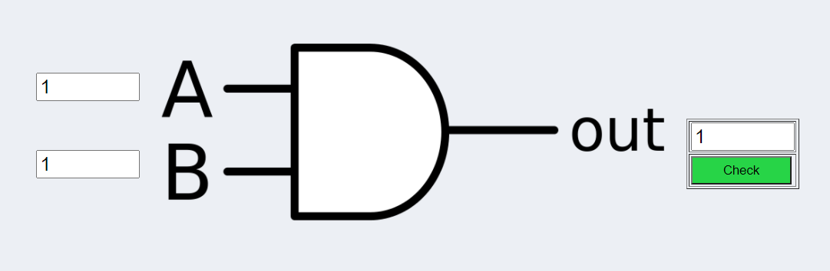

Fig1. Logic Diagram of AND Gate

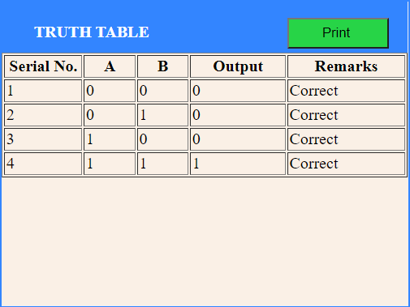

Fig 2. Truth table of AND Gate

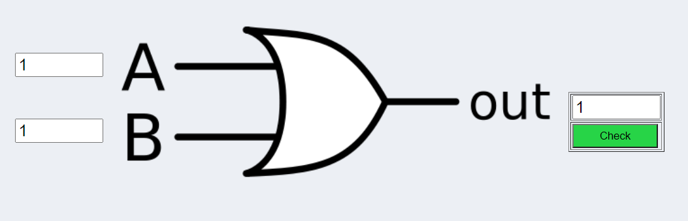

Fig 3. Logic Diagram of OR Gate

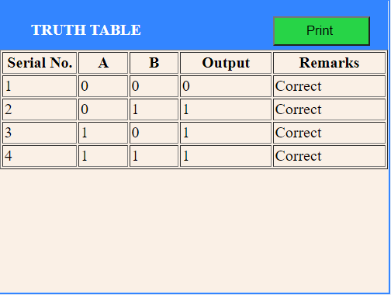

Fig 4. Truth table of OR Gate

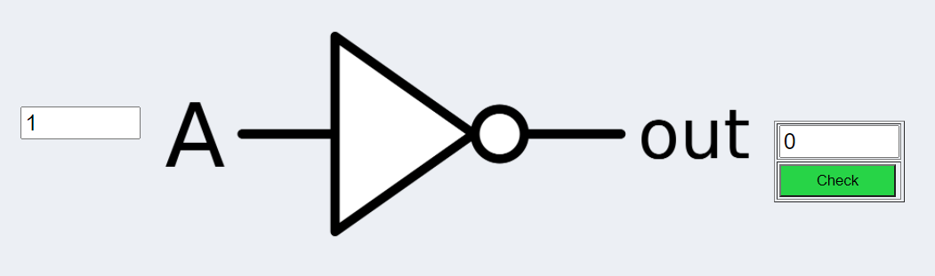

Fig 5. Logic Diagram of NOT Gate

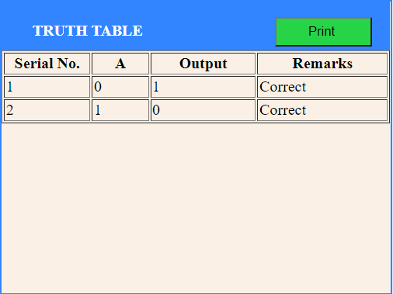

Fig 6. Truth Table of NOT Gate

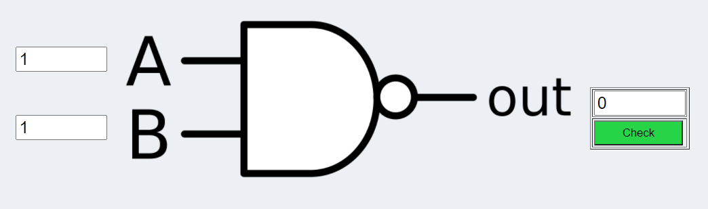

Fig 7. Logic Diagram of NAND Gate

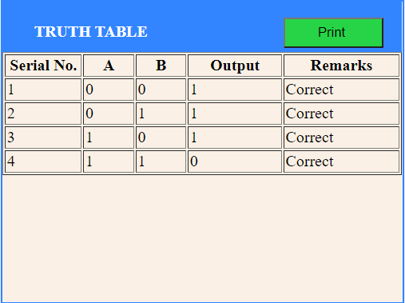

Fig 8. Truth Table of NAND Gate

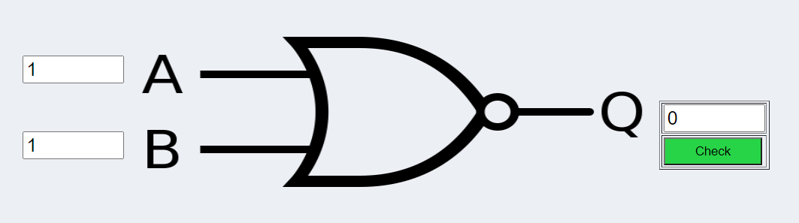

Fig 9. Logic Diagram of NOR Gate

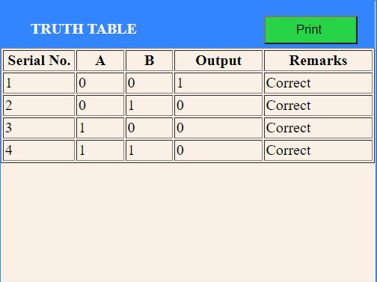

Fig 10. Truth Table of NOR Gate

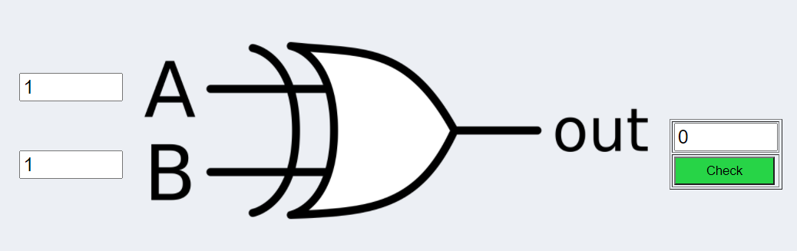

Fig 11. Logic Diagram of XOR Gate

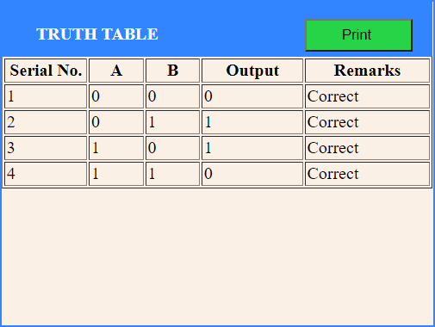

Fig 12. Truth Table of XOR Gate

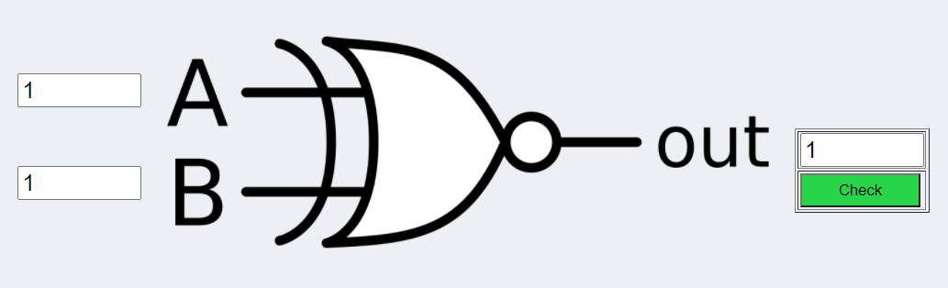

Fig 13. Logic Diagram of XNOR Gate

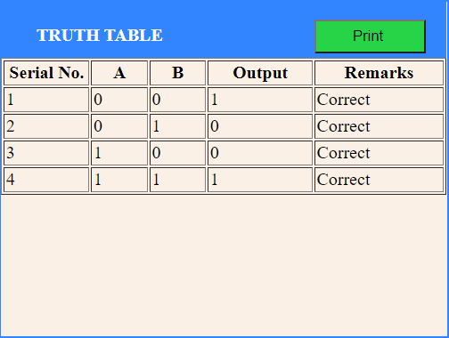

Fig 14. Truth Table of XNOR Gate

**CIRCUIT VERSE**

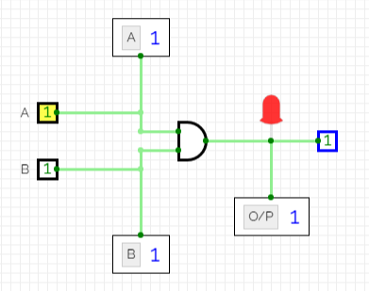

Fig 15. Logic Diagram of AND Gate

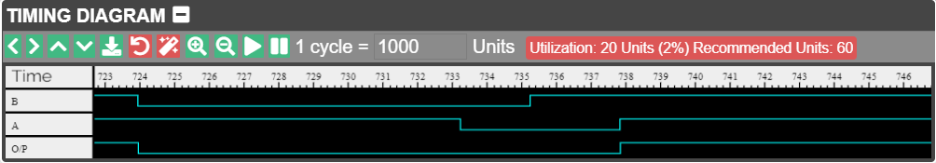

Fig 16. Timing Diagram of AND Gate

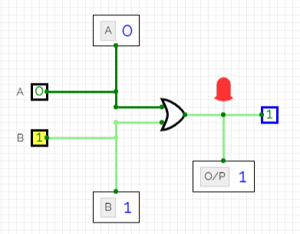

Fig 17. Logic Diagram of OR Gate

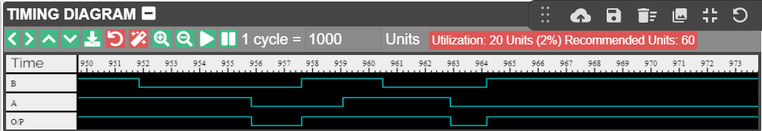

Fig 18. Timing Diagram of OR Gate

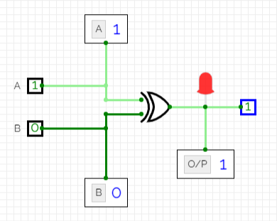

Fig 19. Logic Diagram of XOR Gate

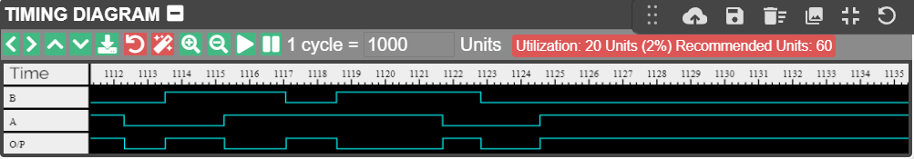

Fig 20. Timing Diagram of XOR Gate

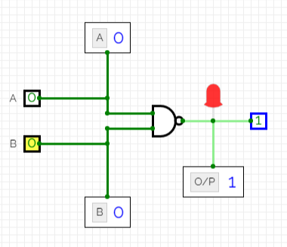

Fig 21. Logic Diagram of NAND Gate

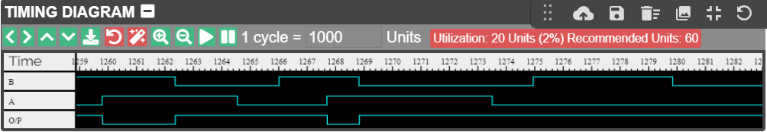

Fig 22. Timing Diagram of NAND Gate

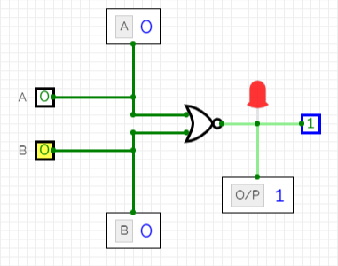

Fig 23. Logic Diagram of NOR Gate

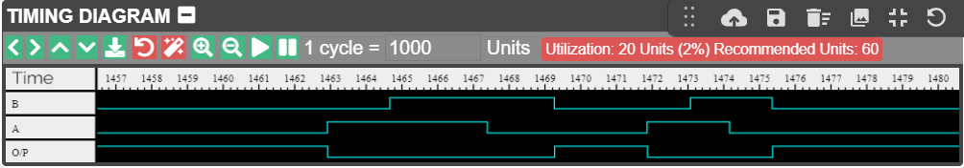

Fig 24. Timing Diagram of NOR Gate

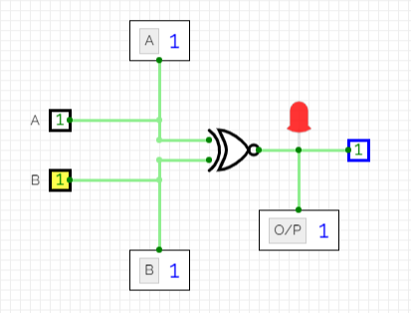

Fig 25. Logic Diagram of XNOR Gate

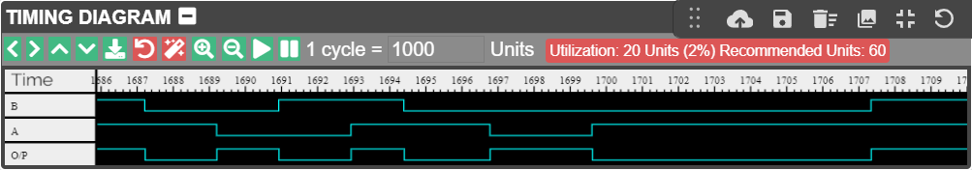

Fig 26. Timing Diagram of XNOR Gate

**RESULT**

Various logic gates have been simulated using virtual labs and circuit verse platforms.

**REFERENCES**

<https://de-iitr.vlabs.ac.in/exp/truth-table-gates/simulation.html>

<https://circuitverse.org/simulator>

**EXPERIMENT 2**

**DATE: 28th July, 2021**

**AIM**

(a) To simulate the 4x1 multiplexer using basic logic gates.

(b) To design 2bit x 2bit combinational multiplier using Half Adder IC and Logic Gates

**SOFTWARE USED**

Virtual lab developed by Ministry of Human Resource Development, Government of India,

Circuit-verse

**THEORY**

4x1 Multiplexer has four data inputs I3, I2, I1 & I0, two selection lines s1 & s0 and one output Y. The block diagram of 4x1 Multiplexer is shown in the following figure.

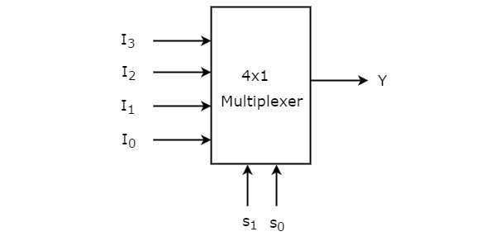

Fig 1. Block diagram of 4x1 Multiplexer

One of these 4 inputs will be connected to the output based on the combination of inputs present at these two selection lines. **Truth table** of 4x1 Multiplexer is shown below.

Table 1. Truth Table of 4X1 Multiplexer

|  |  |  |
| --- | --- | --- |
| **SELECT LINES** | | **OUTPUT** |
| **S1** | **S0** | **Y** |
| 0 | 0 | D0 |
| 0 | 1 | D1 |
| 1 | 0 | D2 |
| 1 | 1 | D3 |

From Truth table, we can directly write the **Boolean function** for output, Y as

[Binary multiplication](https://technobyte.org/2020/01/binary-arithmetic-all-rules-and-operations#Binary_Multiplication) works just like normal multiplication. There are four main rules that are quite simple to understand:

0  x  0  =  0

0  x  1  =  0

1  x  0  =  0

1  x  1  =  1

Suppose you have two binary digits A1A0 and B1B0, here’s how that multiplication would take place

[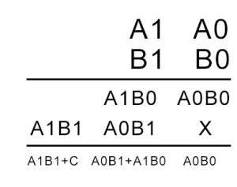](https://i0.wp.com/technobyte.org/wp-content/uploads/2018/09/2-bit-multiplier-digital-2-e1538308782307.jpg?ssl=1)

In the above calculation, A1A0 is the multiplicand. B1B0 is the multiplier. The first product obtained from multiplying B0 with the multiplicand is called as partial product 1. And the second product obtained from multiplying B1 with the multiplicand is known as the partial product 2.

As the number of bits increases, we keep shifting each successive partial product to the left by 1 bit. In the end, we add the digits while keeping in mind the carry that might generate.

Based on the above equation, we can see that we need four [AND gates](https://technobyte.org/2018/09/logic-gates-simplified-deriving-all-gates-using-nand-and-nor-gates#What_is_an_AND_gate) and two [half adders](https://technobyte.org/2018/10/half-adder-full-adder-half-subtractor-full-subtractor#How_to_design_a_Half_Adder_circuit) to design the combinational circuit for the multiplier. The AND gates will perform the multiplication, and the half adders will add the partial product terms. Hence the circuit obtained is as follows.

[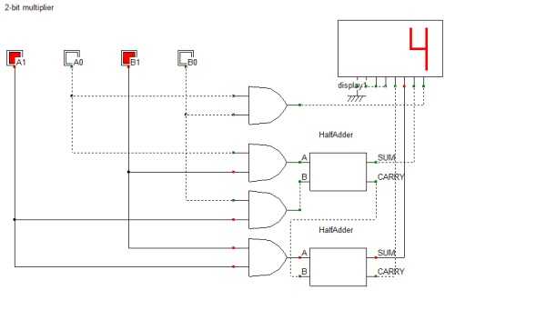](https://i0.wp.com/technobyte.org/wp-content/uploads/2018/09/2-bit-multiplier.png?ssl=1)

Fig 2. Circuit diagram of 2bit x 2bit combinational multiplier

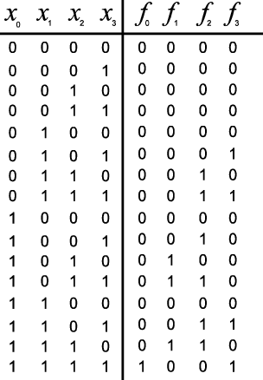

Fig 2. Truth Table of 2bit x 2bit combinational multiplier

**OBSERVATIONS**

**4X1 MULTIPLEXER**

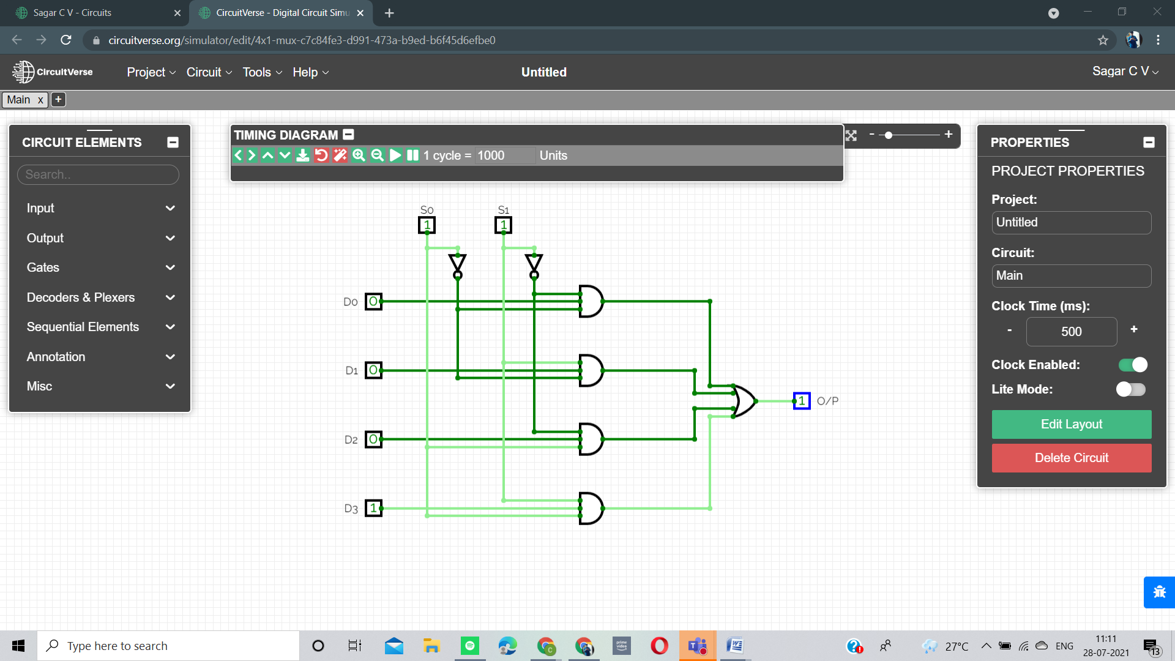

Fig 4. Circuit diagram of 4:1 MUX using basic logic gates when S0 =1 and S1 =1

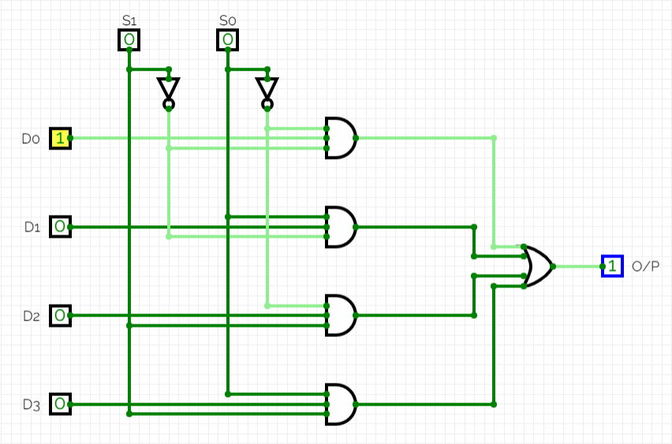

Fig 5. Circuit diagram of 4:1 MUX using basic logic gates when S0 =0 and S1 =0

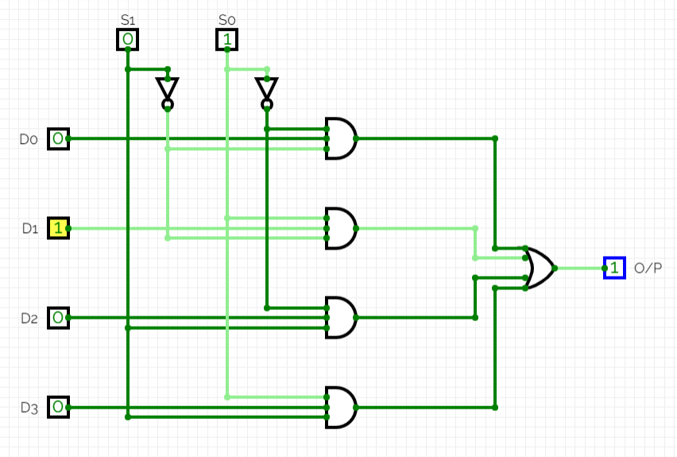

Fig 6. Circuit diagram of 4:1 MUX using basic logic gates when S0 =1 and S1 =0

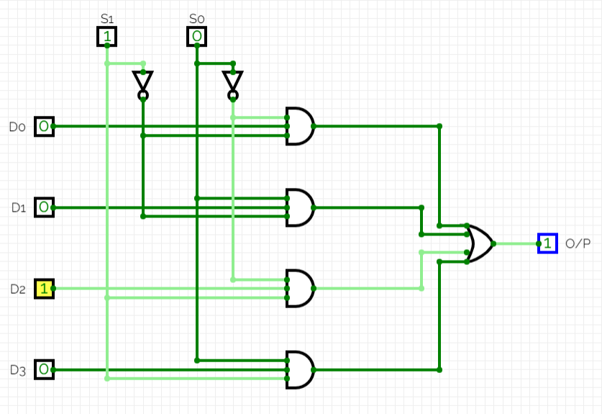

Fig 7. Circuit diagram of 4:1 MUX using basic logic gates when S0 =0 and S1 =1

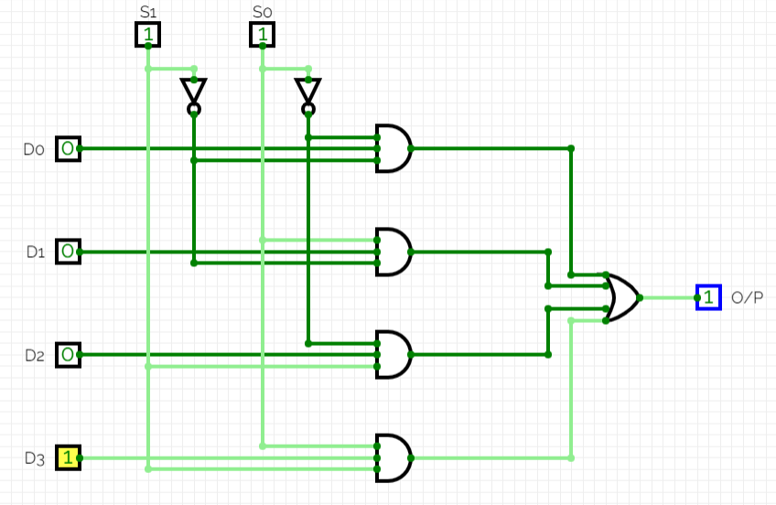

Fig 8. Circuit diagram of 4:1 MUX using basic logic gates when S0 =1 and S1 =1

**2bit x 2bit Combinational Multiplier**

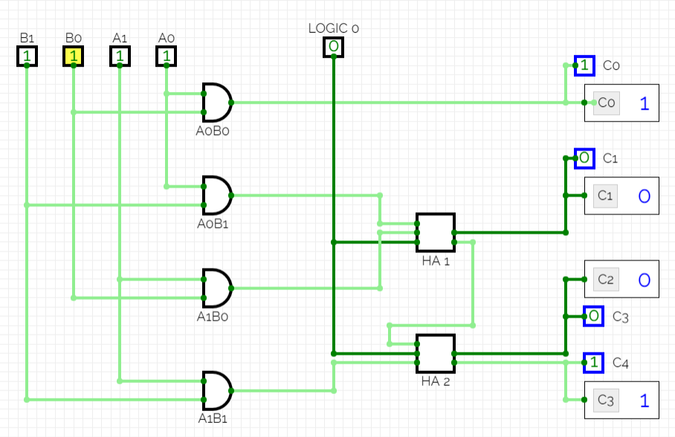

Fig 9. 2bit x 2bit Combinational Multiplier using Half Adder IC and Logic Gates

**RESULT**

4:1 Multiplexer using basic logic gates has been simulated using circuit verse and 2bit x 2bit combinational multiplier using Half adder IC and logic gates has been simulated using circuitverse

**REFERENCES**

<https://circuitverse.org/simulator>

**EXPERIMENT 3**

**DATE: 4th August, 2021**

**AIM**

(a) To stimulate BCD to seven segment decoder using NAND gates.

(b) To stimulate BCD to Gray Code decoder using NAND gates.

**SOFTWARE USED**

Virtual lab developed by Ministry of Human Resource Development, Government of India,

Circuit-verse

**THEORY**

**BCD TO SEVEN SEGMENT**

**Binary Coded Decimal**, or **BCD**, is another process for converting decimal numbers into their binary equivalents.

* It is a form of binary encoding where each digit in a decimal number is represented in the form of bits.
* This encoding can be done in either 4-bit or 8-bit (usually 4-bit is preferred).
* It is a fast and efficient system that converts the decimal numbers into binary numbers as compared to the existing binary system.
* These are generally used in digital displays where is the manipulation of data is quite a task.
* Thus BCD plays an important role here because the manipulation is done treating each digit as a separate single sub-circuit.

Many decimal values, have an infinite place-value representation in binary but have a finite place-value in binary-coded decimal. For example, 0.2 in binary is .001100… and in BCD is 0.0010. It avoids fractional errors and is also used in huge financial calculations.

**Seven Segment Display**

Seven segment displays are the output display device that provide a way to display information in the form of image or text or decimal numbers which is an alternative to the more complex dot matrix displays. It is widely used in digital clocks, basic calculators, electronic meters, and other electronic devices that display numerical information. It consists of seven segments of light emitting diodes (LEDs) which is assembled like numerical 8.

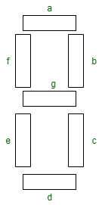

Fig 1. Layout of 7 Segment Display

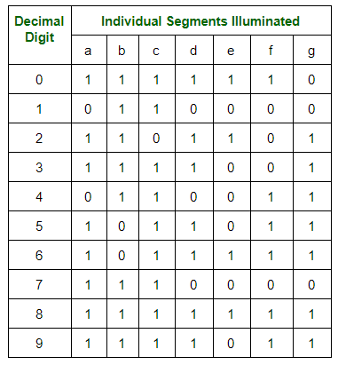

Fig 2. Truth Table of 7 Segment Display for each Decimal Digit

**GRAY CODE**

**Gray Code** has property that two successive numbers differ in only one bit because of this property gray code does the cycling through various states with minimal effort and used in K-maps, error correction, communication etc.Gray Code is a binary number system in which every successive pair of numbers differs in only one bit. It is used in applications in which the normal sequence of binary numbers generated by the hardware may produce an error or ambiguity during the transition from one number to the next

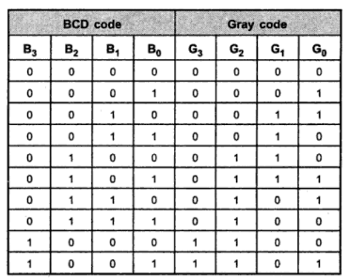

Fig 3. Truth Table of BCD to Gray Code

**OBSERVATIONS**

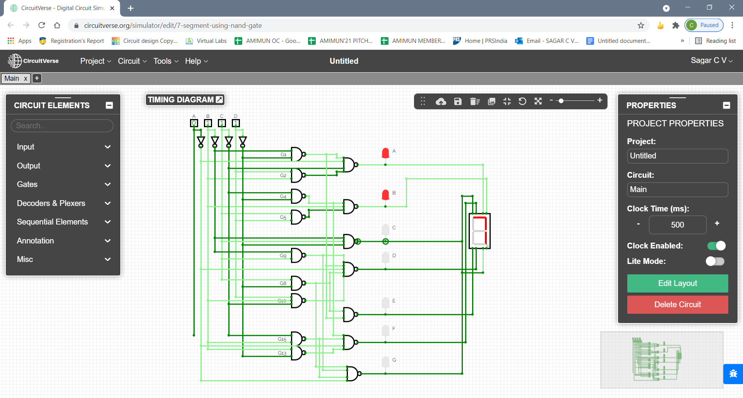

Fig 4. BCD to 7 Segment Display Using NAND GATES showing Digit 7

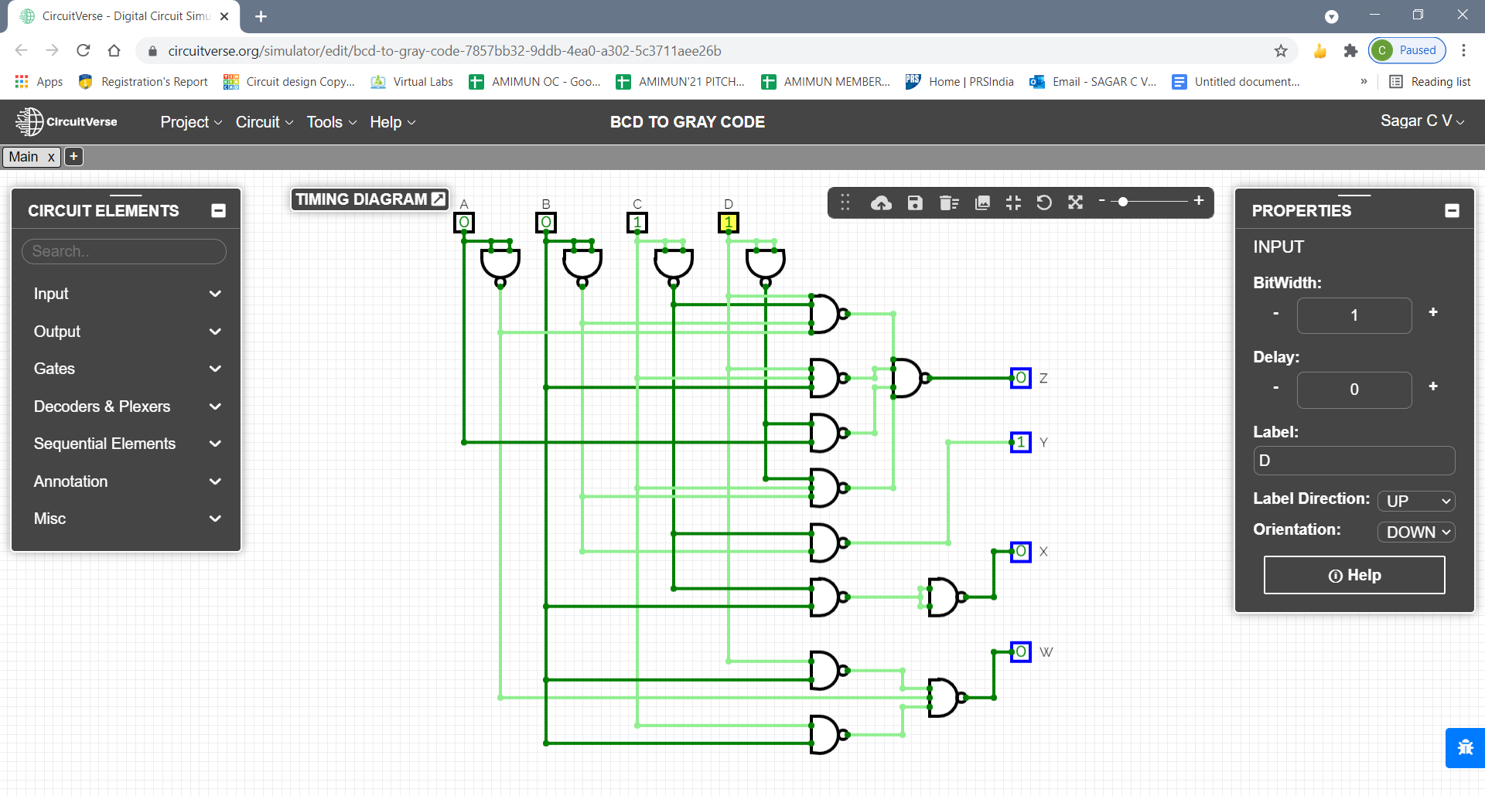

Fig 5. BCD to GRAY Code Converter

**RESULT**

BCD to seven segment decoder using NAND gateshas been simulated using circuitverse.

BCD to Gray Code decoder using NAND gates has been simulated using circuitverse.

**REFERENCES**

<https://circuitverse.org/simulator>

**EXPERIMENT 4**

**DATE: 11th August, 2021**

**AIM**

To design and simulate inverting and non-inverting amplifier with gain more than100 using op amp (uA 741 IC).

**SOFTWARE USED**

Virtual lab developed by Ministry of Human Resource Development, Government of India,

Circuit-verse

**THEORY**

An operational amplifier (often op amp or opamp) is a DC-coupled high-gain electronic voltage amplifier with a differential input and, usually, a single-ended output. ... Op amps may be packaged as components or used as elements of more complex integrated circuits. The op amp is one type of differential amplifier.

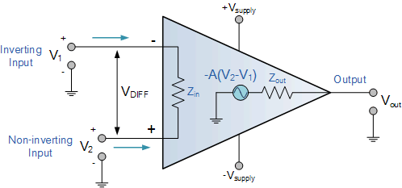

Fig 1. Operational Amplifier

**Inverting Op-Amp**

An inverting amplifier (also known as an inverting operational amplifier or an inverting op-amp) is a type of operational amplifier circuit which produces an output which is out of phase with respect to its input by 180o

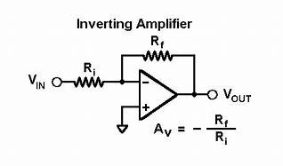

Fig 2. Inverting Op-Amp

**Non Inverting Op-Amp**

In this configuration, the input voltage signal, ( VIN ) is applied directly to the non-inverting ( + ) input terminal which means that the output gain of the amplifier becomes “Positive” in value in contrast to the “Inverting Amplifier” circuit we saw in the last tutorial whose output gain is negative in value. The result of this is that the output signal is “in-phase” with the input signal.

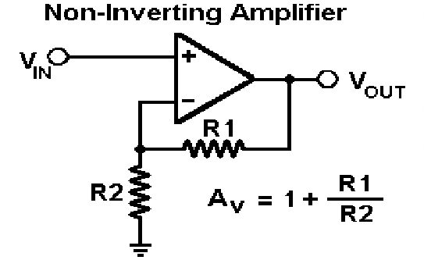

Fig 3. Non Inverting Op-Amp

**CIRCUIT DIAGRAM (VIRTUAL LAB)**

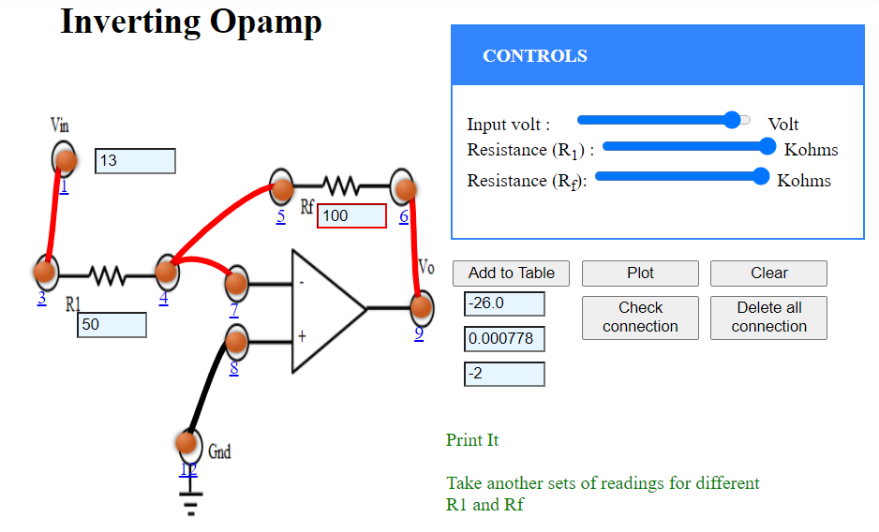

Fig 4. Circuit Diagram for Inverting Op-Amp

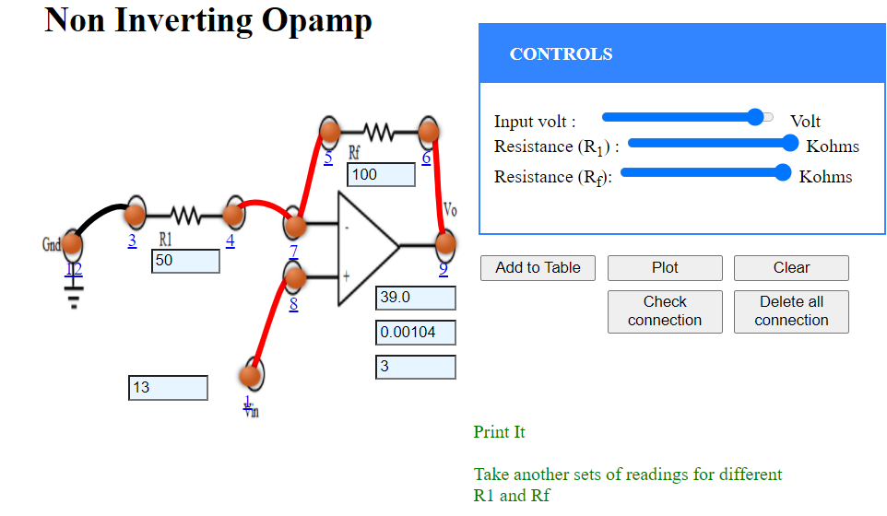

Fig 5. Circuit Diagram for Non-Inverting Op-Amp

**OBSERVATIONS**

**VIRTUAL LAB**

Table 1: Readings for Inverting Op-Amp

**EXPERIMENTAL TABLE**

Resistance: KΩ

|  |  |  |  |
| --- | --- | --- | --- |
| **Serial No.** | **Input Voltage V** | **Output Voltage V** | **Current mA** |
| 1 | -15 | 0.00 | -0.300 |
| 2 | -13 | 26.0 | -0.000778 |
| 3 | -11 | 22.0 | -0.000659 |
| 4 | -9 | 18.0 | -0.000539 |
| 5 | -7 | 14.0 | -0.000419 |
| 6 | -5 | 10.0 | -0.000299 |
| 7 | -3 | 6.00 | -0.000180 |
| 8 | -1 | 2.00 | -0.0000599 |
| 9 | 0 | 0.00 | 0.00 |
| 10 | 1 | -2.00 | 0.0000599 |
| 11 | 3 | -6.00 | 0.000180 |
| 12 | 5 | -10.0 | 0.000299 |
| 13 | 7 | -14.0 | 0.000419 |
| 14 | 9 | -18.0 | 0.000539 |
| 15 | 11 | -22.0 | 0.000659 |

Table 1: Readings for Non-Inverting Op-Amp

**EXPERIMENTAL TABLE**

Resistance: KΩ

|  |  |  |  |
| --- | --- | --- | --- |
| **Serial No.** | **Input Voltage V** | **Output Voltage V** | **Current mA** |
| 1 | -15 | -45.0 | -0.00120 |
| 2 | -13 | -39.0 | -0.00104 |
| 3 | -11 | -33.0 | -0.000878 |
| 4 | -9 | -27.0 | -0.000719 |
| 5 | -7 | -21.0 | -0.000559 |
| 6 | -5 | -15.0 | -0.000399 |
| 7 | -3 | -9.00 | -0.000240 |
| 8 | -1 | -3.00 | -0.0000798 |
| 9 | 1 | 3.00 | 0.0000798 |
| 10 | 3 | 9.00 | 0.000240 |
| 11 | 5 | 15.0 | 0.000399 |
| 12 | 7 | 21.0 | 0.000559 |
| 13 | 9 | 27.0 | 0.000719 |
| 14 | 11 | 33.0 | 0.000878 |
| 15 | 13 | 39.0 | 0.00104 |

**MULTISIM**

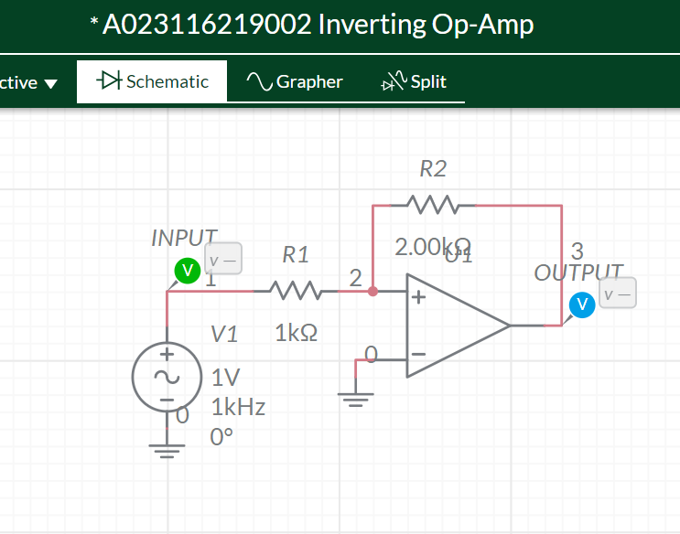

Fig. 6. Circuit diagram of Inverting Op-Amp

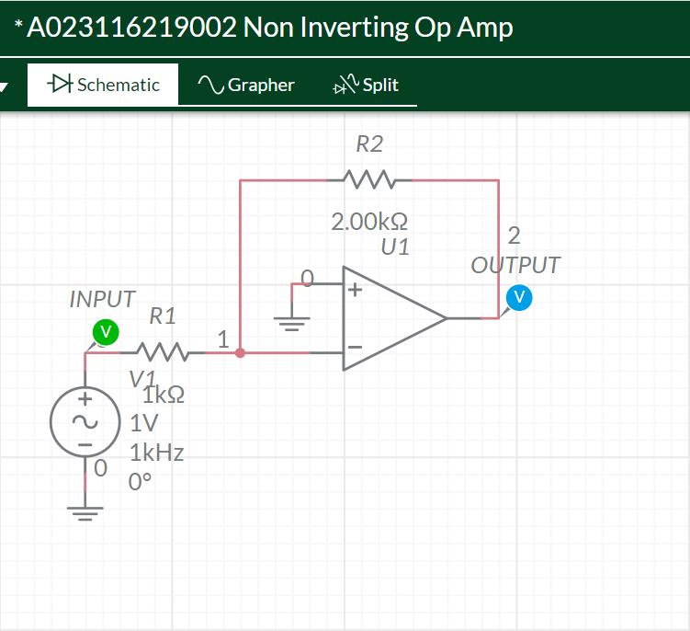

Fig. 7. Circuit diagram of Inverting Op-Amp

**RESULT**

**VIRTUAL LAB**

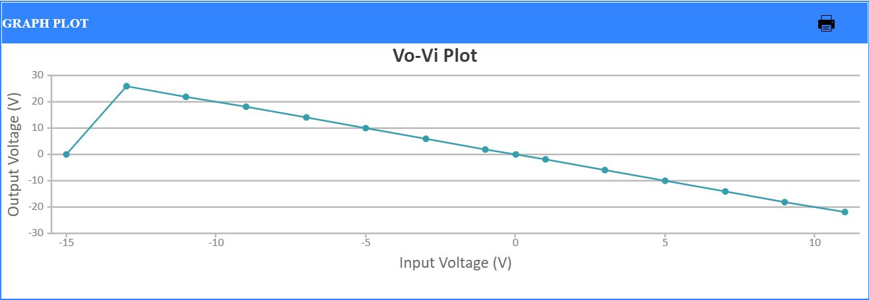

Fig 8. Graph of Inverting Op Amp

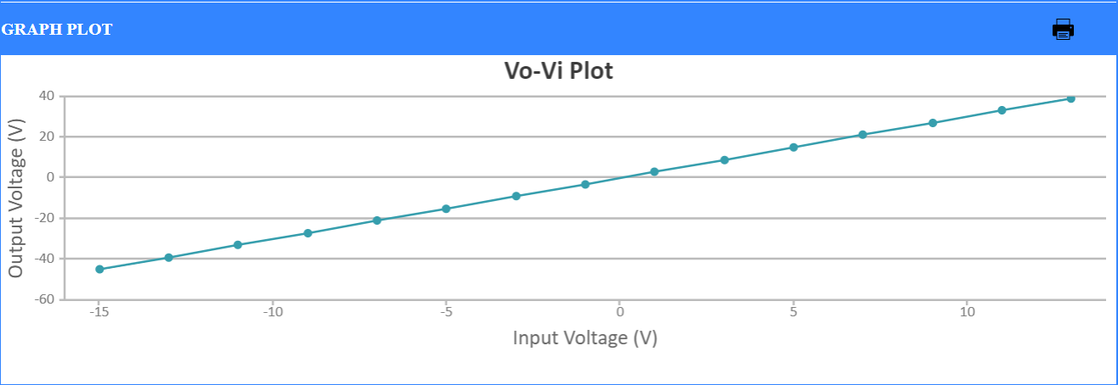

Fig 9. Graph of Non Inverting Op Amp

**MULTISIM**

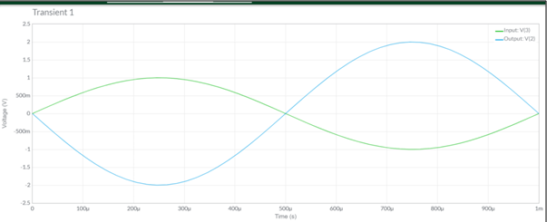

Fig 10. Waveform of Inverting Op Amp

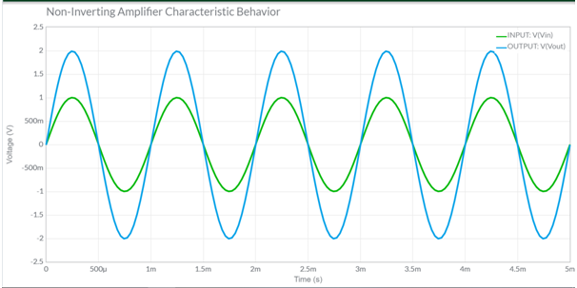

Fig 11. Waveform of Inverting Op Amp

**CONCLUSION**

Inverting Amplifier and Non-Inverting Amplifier using Op-Amp has been simulated using virtual labs and Multisim simulator.

**REFERENCES**

<https://de-iitr.vlabs.ac.in/>

<https://www.multisim.com/>

**EXPERIMENT 5**

**DATE: 11th August, 2021**

**AIM**

To design and simulate Transistor as an amplifier and Integrator & Differentiator using IC uA 741

**SOFTWARE USED**

Virtual lab developed by Ministry of Human Resource Development, Government of India,

Circuit-verse, Falstad, Multisim

**THEORY**

**Integrator Amplifier:**

The Integrator Amplifier is an operational amplifier circuit that performs the mathematical operation of Integration that is we can cause the output to respond to changes in the input voltage over time. The integrator amplifier acts like a storage element that "produces a voltage output which is proportional to the integral of its input voltage with respect to time". In other words the magnitude of the output signal is determined by the length of time a voltage is present at its input as the current through the feedback loop charges or discharges the capacitor as the required negative feedback occurs through the capacitor.

When a voltage, Vin is firstly applied to the input of an integrating amplifier, the uncharged capacitor C has very little resistance and acts a bit like a short circuit (voltage follower circuit) giving an overall gain of less than one. No current flows into the amplifiers input and point X is a virtual earth resulting in zero output. As the feedback capacitor C begins to charge up, its reactance Xc decreases this results in the ratio of Xc/Rin increasing producing an output voltage that continues to increase until the capacitor is fully charged.

At this point the capacitor acts as an open circuit, blocking anymore flow of DC current. The ratio of feedback capacitor to input resistor (Xc/Rin) is now infinite resulting in infinite gain. The result of this high gain (similar to the op-amps open-loop gain), is that the output of the amplifier goes into saturation .Saturation occurs when the output voltage of the amplifier swings heavily to one voltage supply rail or the other with little or no control in between. The ideal voltage output for the Integrator Amplifier as:

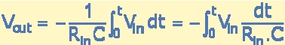

**CIRCUIT DIAGRAM:**

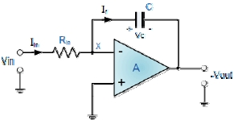  
Fig1. Circuit Diagram of Integrator

**WAVEFORM:**

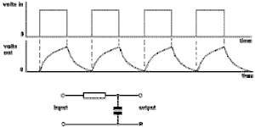

Fig 2. Waverform of Integrator

**DIFFERENTIATOR:**

Differentiator circuits as its name implies, performs the mathematical operation of differentiator, that is, the output waveform is the derivative of the input. The differentiator may be constructed from a basic inverting amplifier when an input resistor R1 is replaced by a capacitor C, Vo= -Rf C d Vin /dt Thus, the output Vo is equal to the Rf C times the negative instantaneous rate of change of the input voltage Vin with time. The right-hand side of the capacitor is held to a voltage of 0 volts, due to the "virtual ground" effect. Therefore, current "through" the capacitor is solely due to change in the input voltage. A steady input voltage won't cause a current through C, but a changing input voltage will. Capacitor current moves through the feedback resistor, producing a drop across it, which is the same as the output voltage. A linear, positive rate of input voltage change will result in a steady negative voltage at the output of the op-amp. Conversely, a linear, negative rate of input voltage change will

result in a steady positive voltage at the output of the op-amp. This polarity inversion from input to output is due to the fact that the input signal is being sent (essentially) to the inverting input of the op-amp, so it acts like the inverting amplifier mentioned previously. The faster the rate of voltage change at the input (either positive or negative), the greater the voltage at the output. The formula for determining voltage output for the differentiator is as follows:



**CIRCUIT DIAGRAM:**

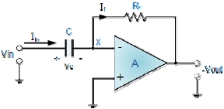

Fig 3. Circuit Diagram of Differentiator

**Common Emitter Amplifier**

In the previous introduction to the amplifier tutorial, we saw that a family of curves known commonly as the **Output Characteristic Curves**, relate the transistors Collector Current (Ic), to its Collector Voltage (Vce) for different values of the transistors Base Current (Ib).

All types of transistor amplifiers operate using AC signal inputs which alternate between a positive value and a negative value so some way of “presetting” the amplifier circuit to operate between these two maximum or peak values is required. This is achieved using a process known as **Biasing**. Biasing is very important in amplifier design as it establishes the correct operating point of the transistor amplifier ready to receive signals, thereby reducing any distortion to the output signal.

**OBSERVATIONS**

**Multisim**

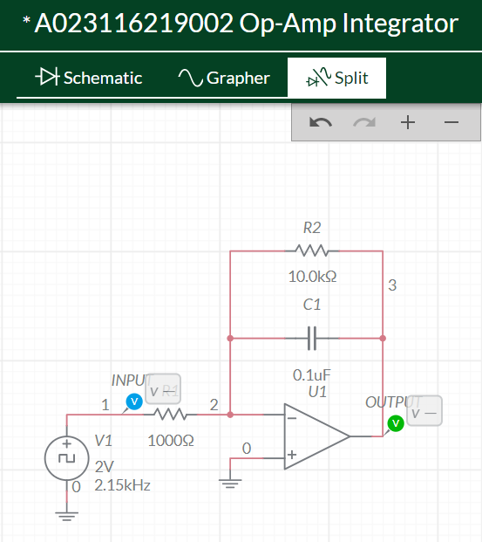

Fig 4. Circuit diagram of Integrator

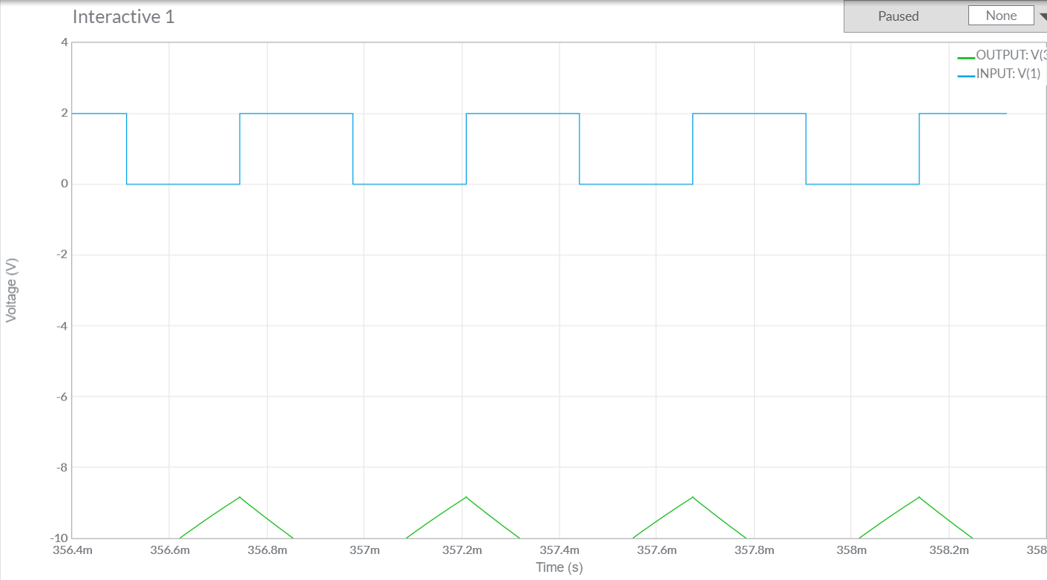

Fig 5. Waveform of Integrator

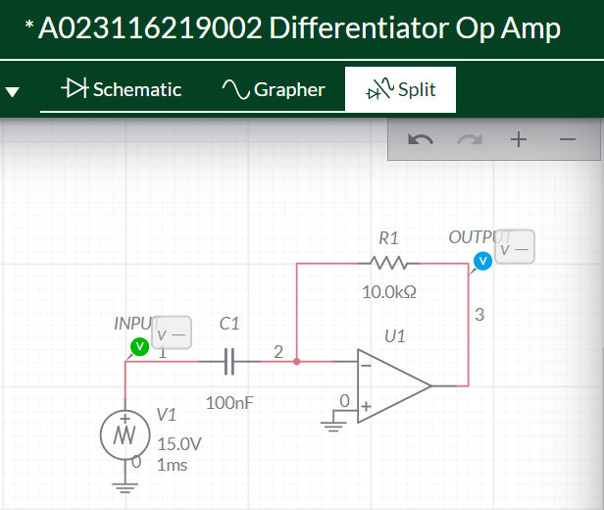

Fig 6. Circuit Diagram of Differentiator

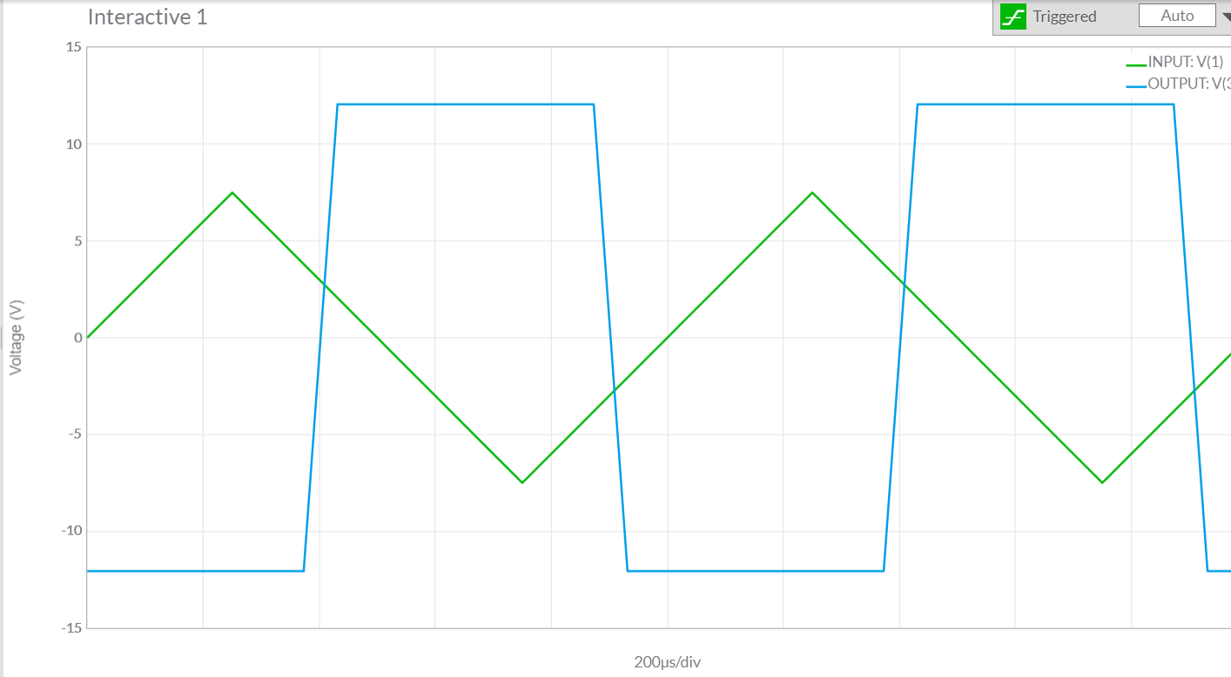

Fig 7. Waveform of Differentiator

**Falstad**

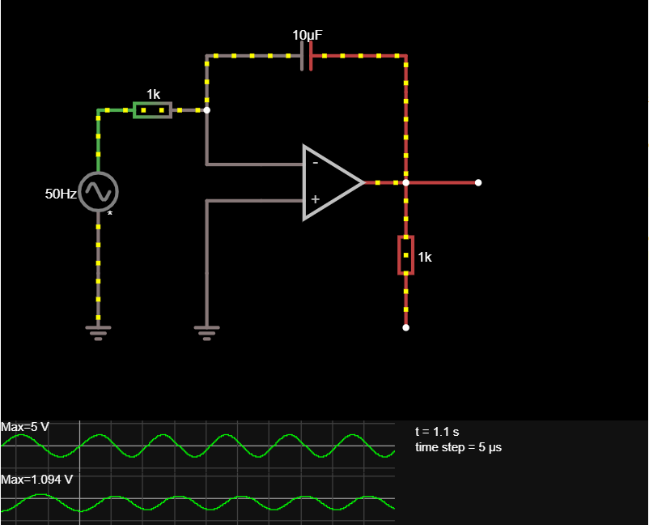

Fig 8. Circuit diagram and waveform of Integrator

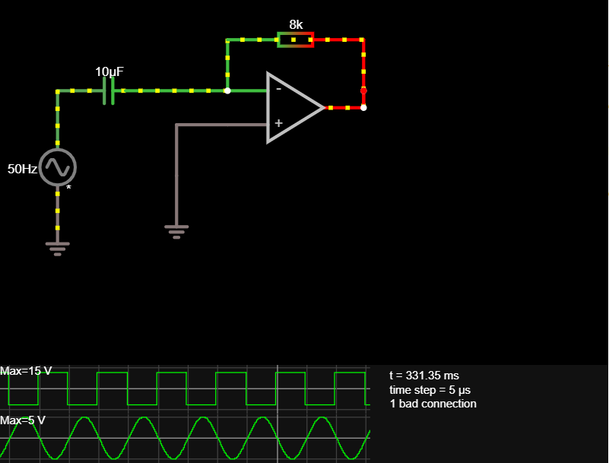

Fig 9. Circuit diagram and waveform of Integrator

**VIRTUAL LAB**

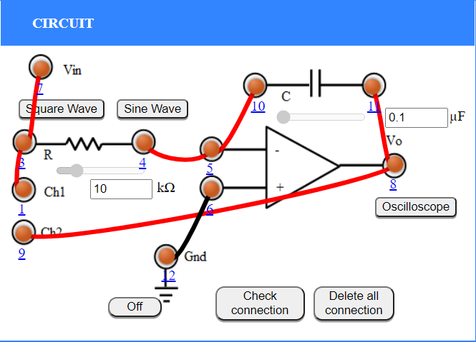

Fig 10. Circuit Diagram of Integrator

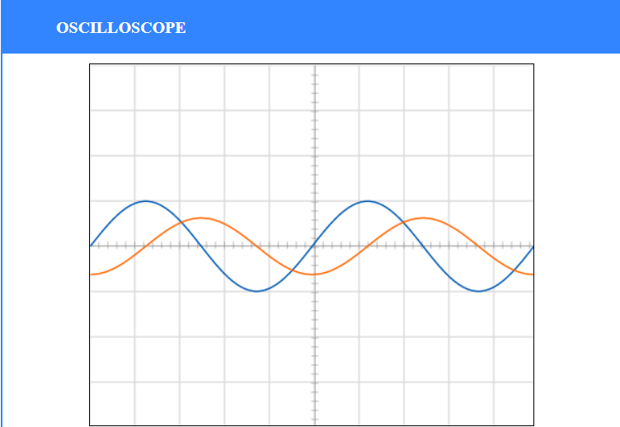

Fig 11. Waveform of Integrator

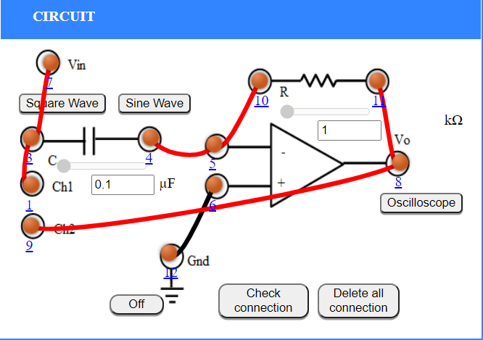

Fig 12. Circuit Diagram of Differentiator

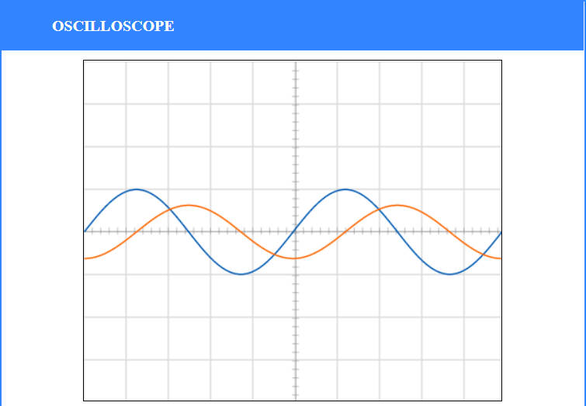

Fig 13. Waveform of Differentiator

**COMMON EMITTER**

Table 1. Observation table for CE Amplifier

|  |  |  |
| --- | --- | --- |
| **Serial No.** | **Frequency(Hz)** | **Magnitude(dB)** |
| 1 | 50 | 10.599 |
| 2 | 80 | 14.39246 |
| 3 | 115 | 17.48112 |
| 4 | 152 | 19.7911 |
| 5 | 200 | 22.0672 |
| 6 | 264 | 24.2756 |
| 7 | 290 | 24.9892 |
| 8 | 348 | 26.369600000000002 |
| 9 | 382 | 27.0322 |
| 10 | 503 | 28.878400000000003 |
| 11 | 875 | 31.724 |
| 12 | 1386 | 33.126400000000004 |
| 13 | 2004 | 33.7386 |
| 14 | 2641 | 34.0028 |
| 15 | 4186 | 34.2308 |
| 16 | 8746 | 34.3518 |
| 17 | 41862 | 34.3864 |
| 18 | 105153 | 34.3842 |
| 19 | 289614 | 34.3574 |
| 20 | 381786 | 34.3346 |
| 21 | 727478 | 34.1956 |
| 22 | 1386180 | 33.7256 |
| 23 | 2196950 | 32.8832 |
| 24 | 4186200 | 30.401799999999998 |
| 25 | 50329200 | 10.99534 |

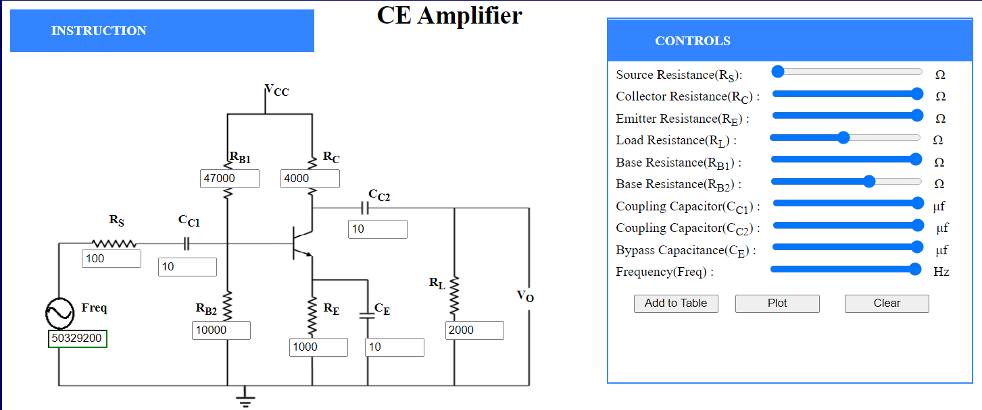

Fig 14. Circuit Diagram of CE Amplifier

**RESULT**

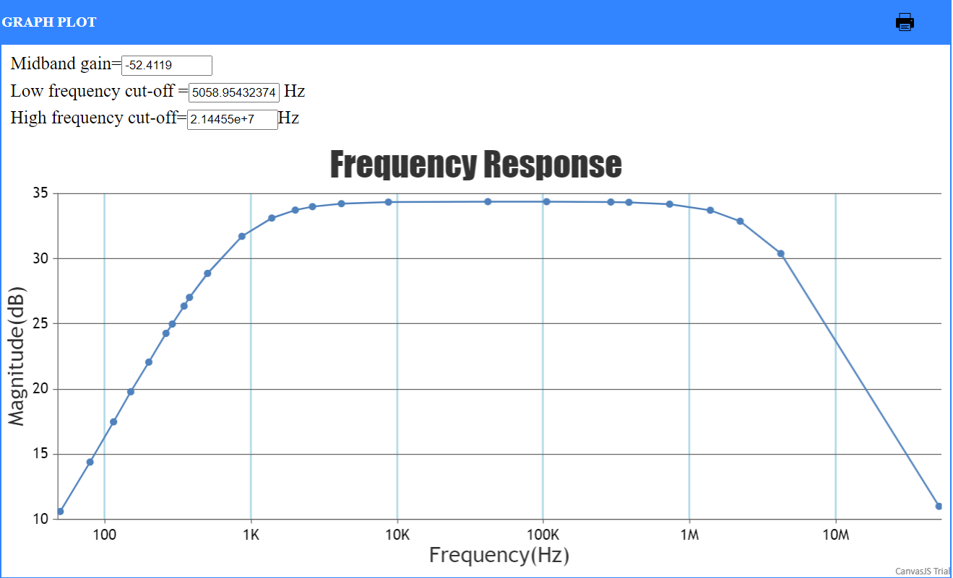

Fig 15. Graph of CE Amplifier

**CONCLUSION**

Transistor as an amplifier and Integrator & Differentiator using IC uA 741 has been simulated using virtual labs and Multisim simulator.

**EXPERIMENT 6**

**DATE: 25th August, 2021**

**AIM**

Create a VI to study the operation of Logic Gates and view their output.

**SOFTWARE USED**

LabView Software

**THEORY**

Logic gates are the basic building blocks of any digital system. It is an electronic circuit having one or more than one input and only one output. The relationship between the input and the output is based on certain logic. Based on this, logic gates are named as AND gate, OR gate, NOT gate etc.

The AND gate is so named because, if 0 is called "false" and 1 is called "true," the gate acts in the same way as the logical "and" operator. The following illustration and table show the circuit symbol and logic combinations for an AND gate. (In the symbol, the input terminals are at left and the output terminal is at right.) The output is "true" when both inputs are "true." Otherwise, the output is "false." In other words, the output is 1 only when both inputs one AND two are 1.

The OR gate gets its name from the fact that it behaves after the fashion of the logical inclusive "or." The output is "true" if either or both of the inputs are "true." If both inputs are "false," then the output is "false." In other words, for the output to be 1, at least input one OR two must be 1.

The XOR ( exclusive-OR ) gate acts in the same way as the logical "either/or." The output is "true" if either, but not both, of the inputs are "true." The output is "false" if both inputs are "false" or if both inputs are "true." Another way of looking at this circuit is to observe that the output is 1 if the inputs are different, but 0 if the inputs are the same.

A logical inverter, sometimes called a NOT gate to differentiate it from other types of electronic inverter devices, has only one input. It reverses the logic state. If the input is 1, then the output is 0. If the input is 0, then the output is 1.

The NAND gate operates as an AND gate followed by a NOT gate. It acts in the manner of the logical operation "and" followed by negation. The output is "false" if both inputs are "true." Otherwise, the output is "true."

The NOR gate is a combination OR gate followed by an inverter. Its output is "true" if both inputs are "false." Otherwise, the output is "false."

The XNOR (exclusive-NOR) gate is a combination XOR gate followed by an inverter. Its output is "true" if the inputs are the same, and "false" if the inputs are different.

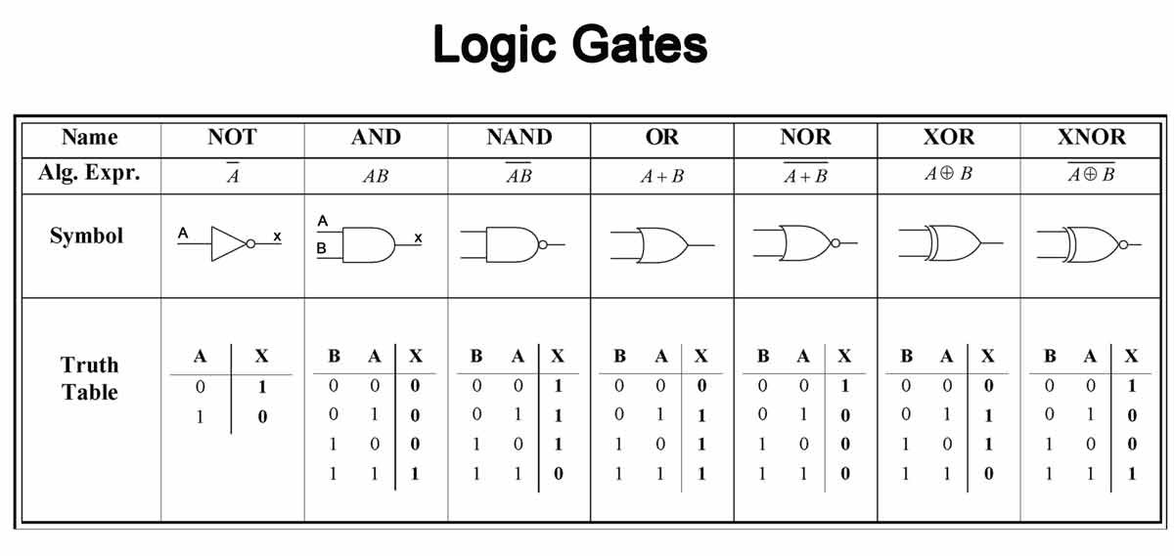

Fig 1. Truth Table and Logic Diagram of NOT, AND, NAND, OR, NOR, XOR, XNOR Logic Gates

**OBSERVATIONS**

**LABVIEW SOFTWARE**

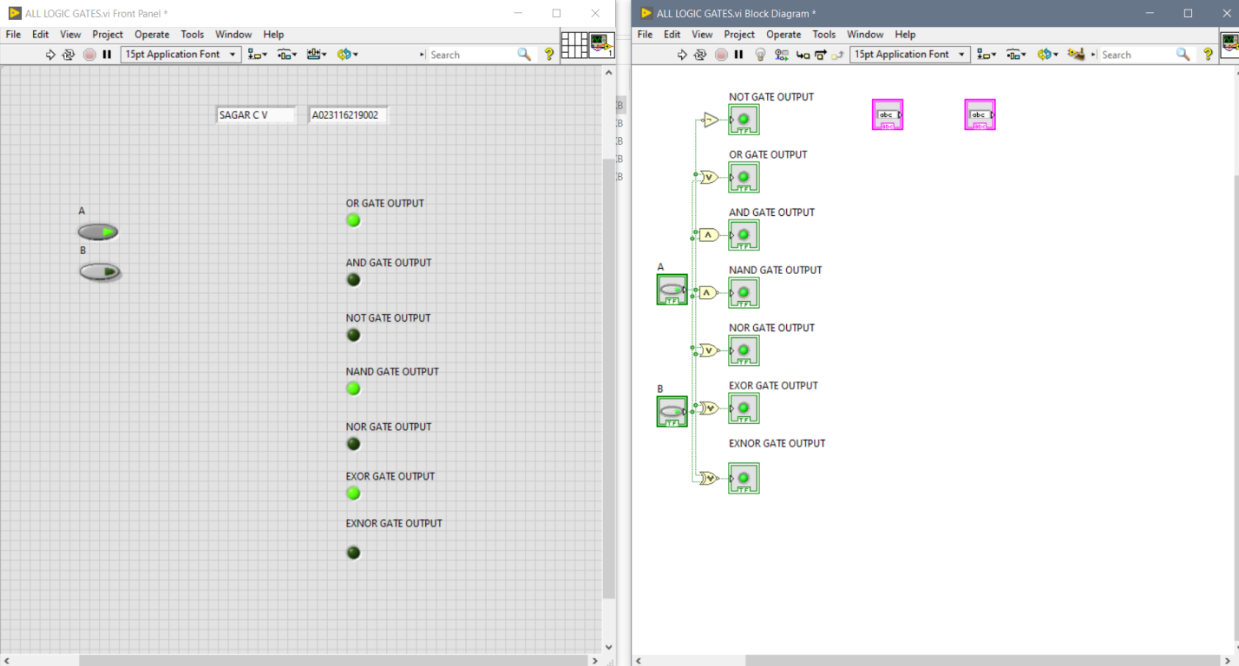

Fig 2. Logic Diagram and working of LOGIC Gates in Labview Software

**CONCLUSION**

Hence we created VI to study the operation of Logic Gates and view their output on Lab View Software.

**EXPERIMENT 7**

**DATE: 1st September, 2021**

**AIM**

Create a VI to implement the Hald adder, Full adder, Half subtractor and Full subtractor.

**SOFTWARE USED**

LabView Software

**THEORY**

### HALF ADDER CIRCUIT

Adder circuit is a combinational digital circuit that is used for adding two numbers. A typical adder circuit produces a sum bit (denoted by SUM) and a carry bit (denoted by CARRY) as the output.

Typically adders are realized for adding binary numbers but they can be also realized  for adding other formats like BCD (binary coded decimal, XS-3 etc.

Besides addition, adder circuits can be used for a lot of other applications in digital electronics like address decoding, table index calculation etc.

* **Adder circuits are of two types:**

1. **Half adder**
2. **Full adder.**

Half adder is a combinational arithmetic circuit that adds two numbers and produces a sum bit (SUM) and carry bit (CARRY) as the output. If A and B are the input bits, then sum bit (SUM) is the X-OR of A and B  and the carry bit (CARRY) will be the AND of A and B.

A half adder circuit can be easily constructed using one X-OR gate and one AND gate.

The truth table, schematic representation and XOR//AND realization of a half adder are shown in the figure below.

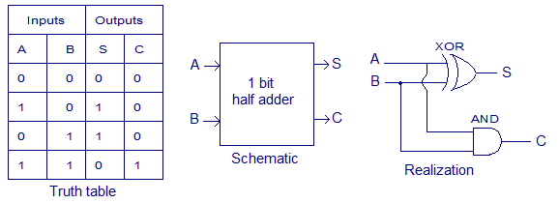

Fig 1. Truth Table, Schematic and Realization of Half Adder

**LOGICAL EXPRESSION:**

**Sum = A XOR B**  
**Carry = A AND B**

# FULL ADDER IN DIGITAL LOGIC

* Full Adder is the adder which adds three inputs and produces two outputs. The first two inputs are A and B and the third input is an input carry as C-IN. The output carry is designated as C-OUT and the normal output is designated as S which is SUM.
* A full adder logic is designed in such a manner that can take eight inputs together to create a byte-wide adder and cascade the carry bit from one adder to the another.

**SCHEMATIC**

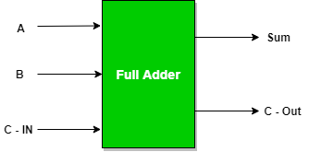

Fig 2. Schematic of Full Adder Circuit

**TRUTH TABLE:**

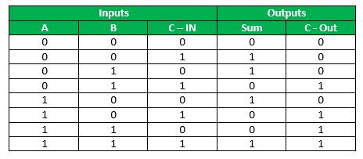

Fig 3. Truth Table of Full Adder Circuit

**SUBTRACTOR**

Subtractor circuits take two binary numbers as input and subtract one binary number input from the other binary number input. Similar to adders, it gives out two outputs, difference and borrow (carry-in the case of Adder). There are two types of subtractors.

1) Half Subtractor  
2) Full Subtractor

**HALF SUBTRACTOR**

The half-subtractor is a combinational circuit which is used to perform subtraction of two bits. It has two inputs, A (minuend) and B (subtrahend) and two outputs Difference and Borrow. The logic symbol and truth table are shown below.

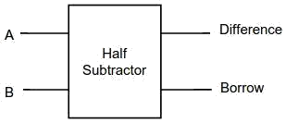  
Fig 4. Logic Symbol of Half subtractor

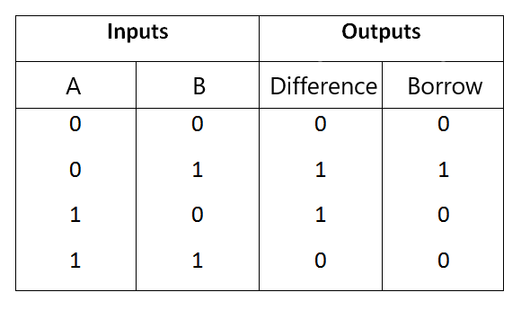  
Fig 5. Truth Table of Half subtractor

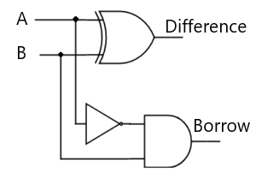

Fig 6. Circuit Diagram of Half subtractor

From the above truth table we can find the boolean expression.

**Difference = A ⊕ B  
Borrow = A' B**

From the equation we can draw the half-subtractor circuit as shown in the figure 3.

**FULL SUBTRACTOR**

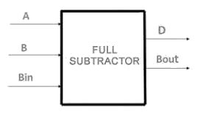A full subtractor is a combinational circuit that performs subtraction involving three bits, namely A (minuend), B (subtrahend), and Bin (borrow-in) . It accepts three inputs: A (minuend), B (subtrahend) and a Bin (borrow bit) and it produces two outputs: D (difference) and Bout (borrow out). The logic symbol and truth table are shown below.

Fig 7. Logic Symbol of Full subtractor

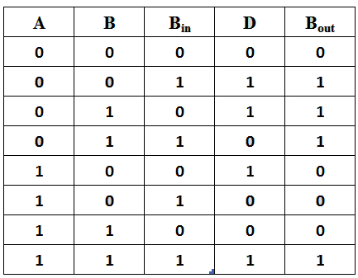  
Fig 8. Truth Table of Full subtractor

From the above truth table we can find the boolean expression.

**D = A ⊕ B ⊕ Bin  
Bout = A' Bin + A' B + B Bin**

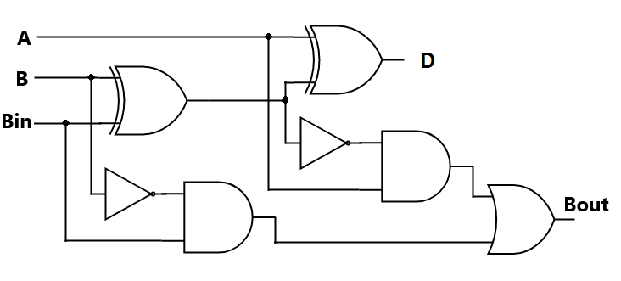From the equation we can draw the Full-subtractor circuit as shown in the figure 6.

Fig 9. Circuit Diagram of Full subtractor

**OBSERVATIONS**

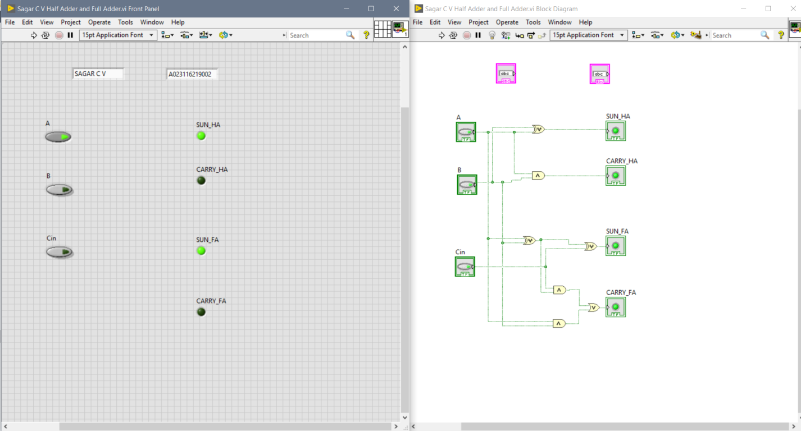

Fig 10. Half Adder and Full Adder using LabView Software

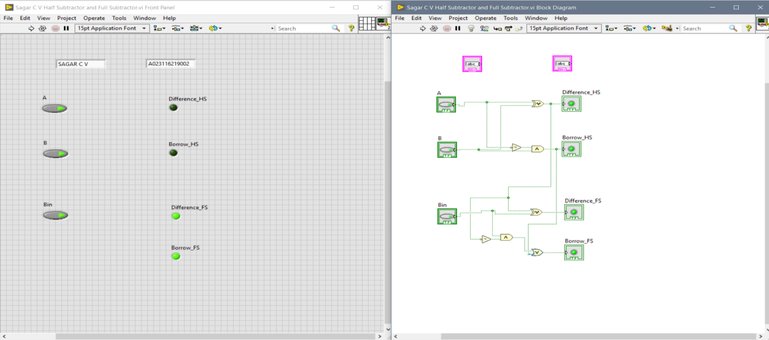

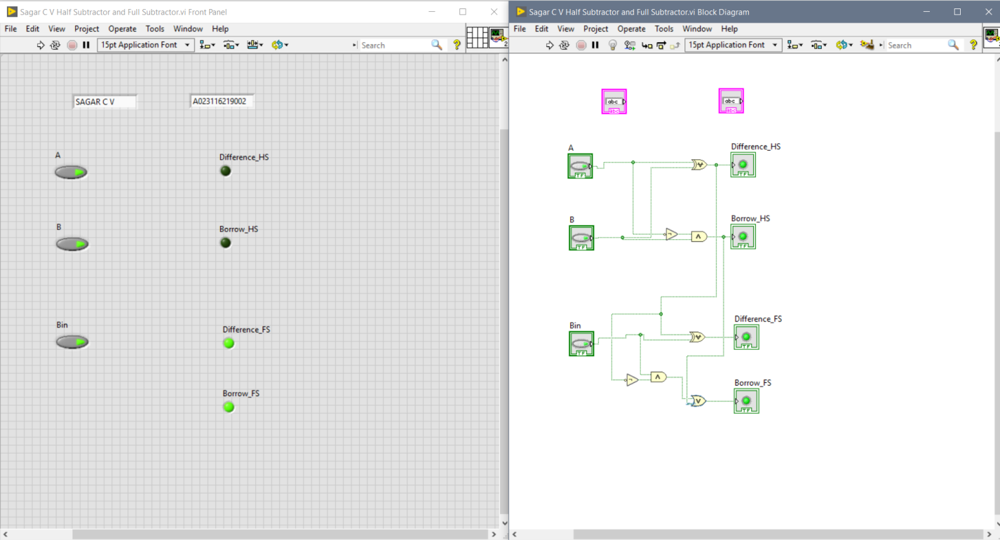

Fig 11. Half Subtractor and Full Subtractor using LabView Software

**CONCLUSION**

Hence we created VI to implement the Hald adder, Full adder, Half subtractor and Full subtractor on Lab View Software.

**EXPERIMENT 8**

**DATE: 8th September, 2021**

**AIM**

Create a VI to simulate series RLC circuit and plot the graph of Current and Impedance vs Frequency

**SOFTWARE USED**

LabView Software

**THEORY**

The series RLC circuit above has a single loop with the instantaneous current flowing through the loop being the same for each circuit element. Since the inductive and capacitive reactance’s XL and XC are a function of the supply frequency, the sinusoidal response of a series RLC circuit will therefore vary with frequency, ƒ. Then the individual voltage drops across each circuit element of R, L and C element will be “out-of-phase” with each other as defined by:

* i(t) = Imax sin(ωt)
* The instantaneous voltage across a pure resistor, VR is “in-phase” with current
* The instantaneous voltage across a pure inductor, VL “leads” the current by 90o
* The instantaneous voltage across a pure capacitor, VC “lags” the current by 90o
* Therefore, VL and VC are 180o “out-of-phase” and in opposition to each other.

For the series RLC circuit above, this can be shown as:

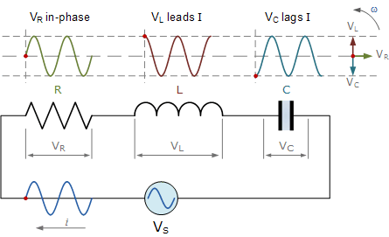

Fig 1. Circuit Diagram of Series RLC Circuit

The amplitude of the source voltage across all three components in a series RLC circuit is made up of the three individual component voltages, VR, VL and VC with the current common to all three components.

**OBSERVATIONS**

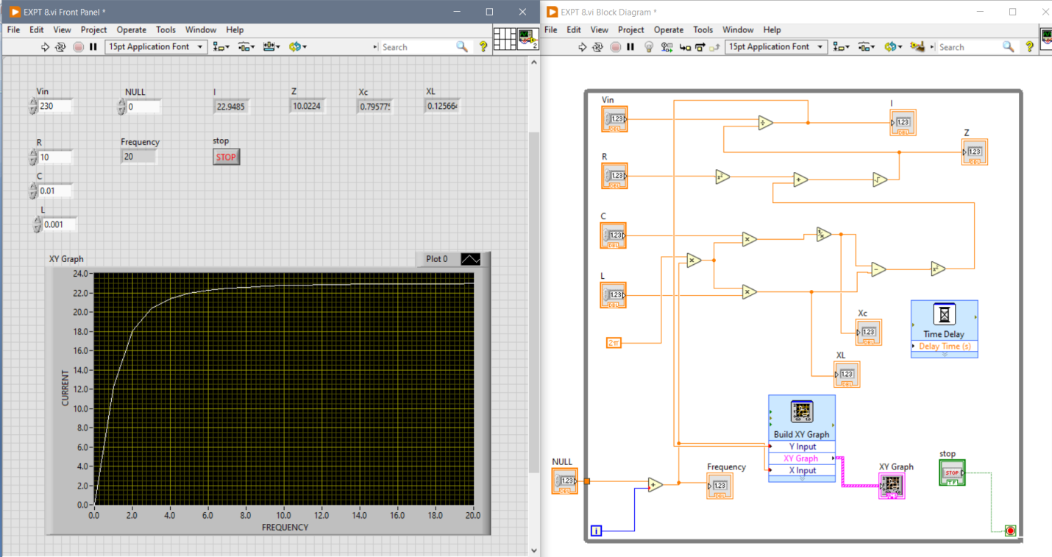

Fig 1. RLC Graph and Circuit on LabVIEW software

**CALCULATION**

$$fr=\frac{1}{2π\sqrt{LC}}$$

$$fr=\frac{1}{2π\sqrt{0.001*0.01}}$$

$$fr=50.3 Hz$$

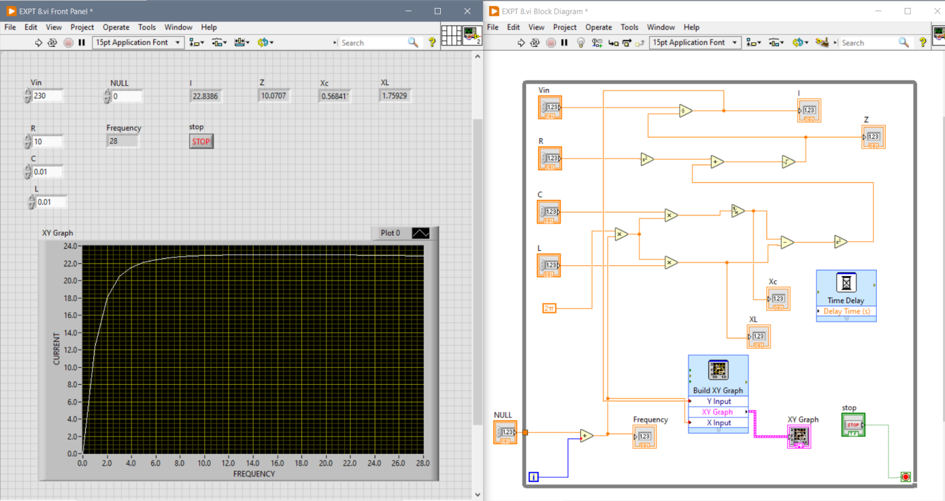

Fig 2. RLC Graph and Circuit on LabVIEW software

**CALCULATION**

$$fr=\frac{1}{2π\sqrt{LC}}$$

$$fr=\frac{1}{2π\sqrt{0.01*0.01}}$$

$$fr=15.91 Hz$$

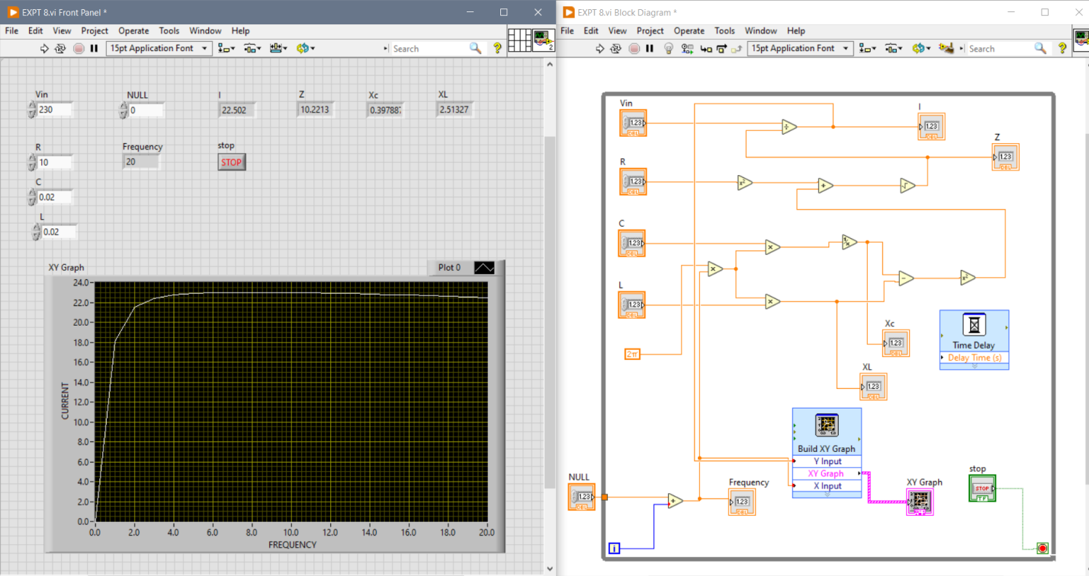

**CALCULATION**

$$fr=\frac{1}{2π\sqrt{LC}}$$

$$fr=\frac{1}{2π\sqrt{0.02*0.02}}$$

$$fr=7.96 Hz$$

**CONCLUSION**

Hence we created VI to simulate series RLC circuit and plot the graph of Current and Impedance vs Frequency on Lab View Software.

**EXPERIMENT 9**

**DATE: 22nd September, 2021**

**AIM**

Create a VI to implement the comparator operation and verify the output logic

**SOFTWARE USED**

LabView Software

**THEORY**

A magnitude digital Comparator is a combinational circuit that **compares two digital or binary numbers** in order to find out whether one binary number is equal, less than or greater than the other binary number. We logically design a circuit for which we will have two inputs one for A and other for B and have three output terminals, one for A > B condition, one for A = B condition and one for A < B condition.

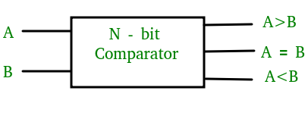

Fig 1. Block Diagram of Comparator

### 2-Bit Magnitude Comparator –

A comparator used to compare two binary numbers each of two bits is called a 2-bit Magnitude comparator. It consists of four inputs and three outputs to generate less than, equal to and greater than between two binary numbers.

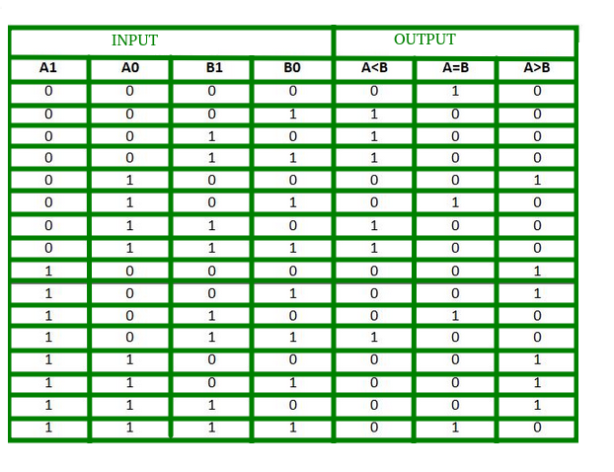

Fig 2. Truth table of 2bit Comparator

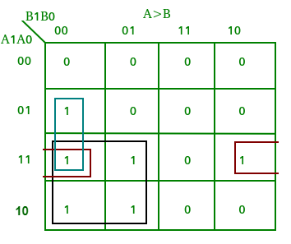

Fig 3. KMap of output A>B

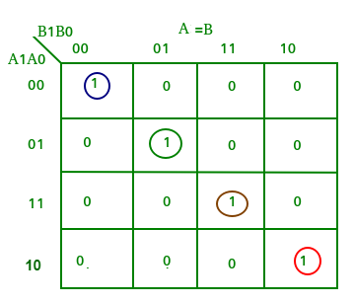

Fig 4. KMap of output A=B

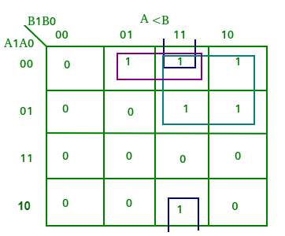

Fig 5. KMap of output A<B

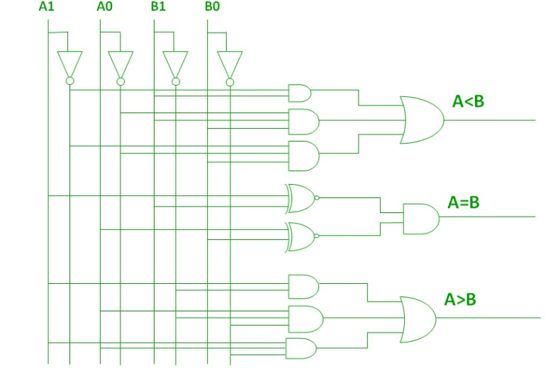

Fig 6. Logic Circuit of Comparator

**OBSERVATIONS**

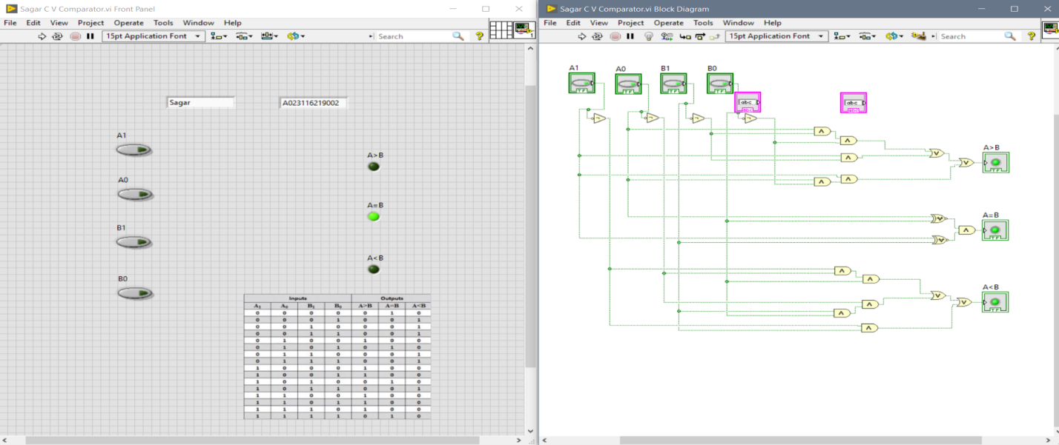

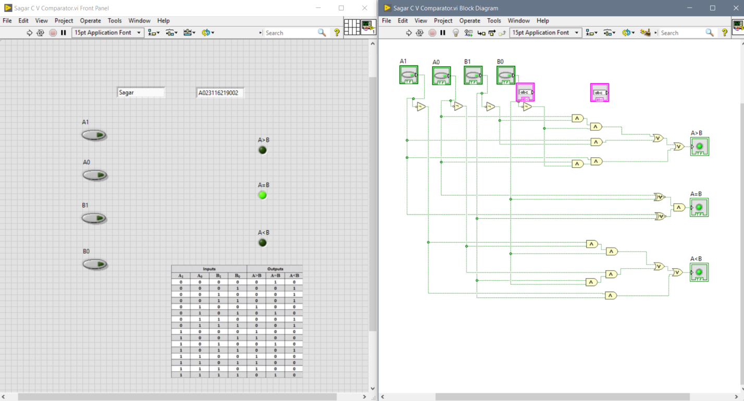

Fig 7.Comparator on LabVIEW Software

**CONCLUSION**

Hence we created VI to implement the comparator operation and verify the output logic using the Labview Software

**EXPERIMENT 10**

**DATE: 29th September, 2021**

**AIM**

Create a VI to implement 4 : 1 Multiplexer

**SOFTWARE USED**

LabView Software

**THEORY**

It is a combinational circuit which have many data inputs and single output depending on control or select inputs.​ For N input lines, log n (base2) selection lines, or we can say that for 2n input lines, n selection lines are required. Multiplexers are also known as **“Data n selector, parallel to serial convertor, many to one circuit, universal logic circuit​”**. Multiplexers are mainly used to increase amount of the data that can be sent over the network within certain amount of time and bandwidth.

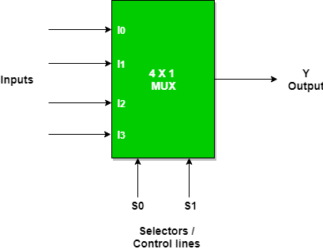

Fig 1. Block Diagram of 4:1 Multiplexer

**OBSERVATIONS**

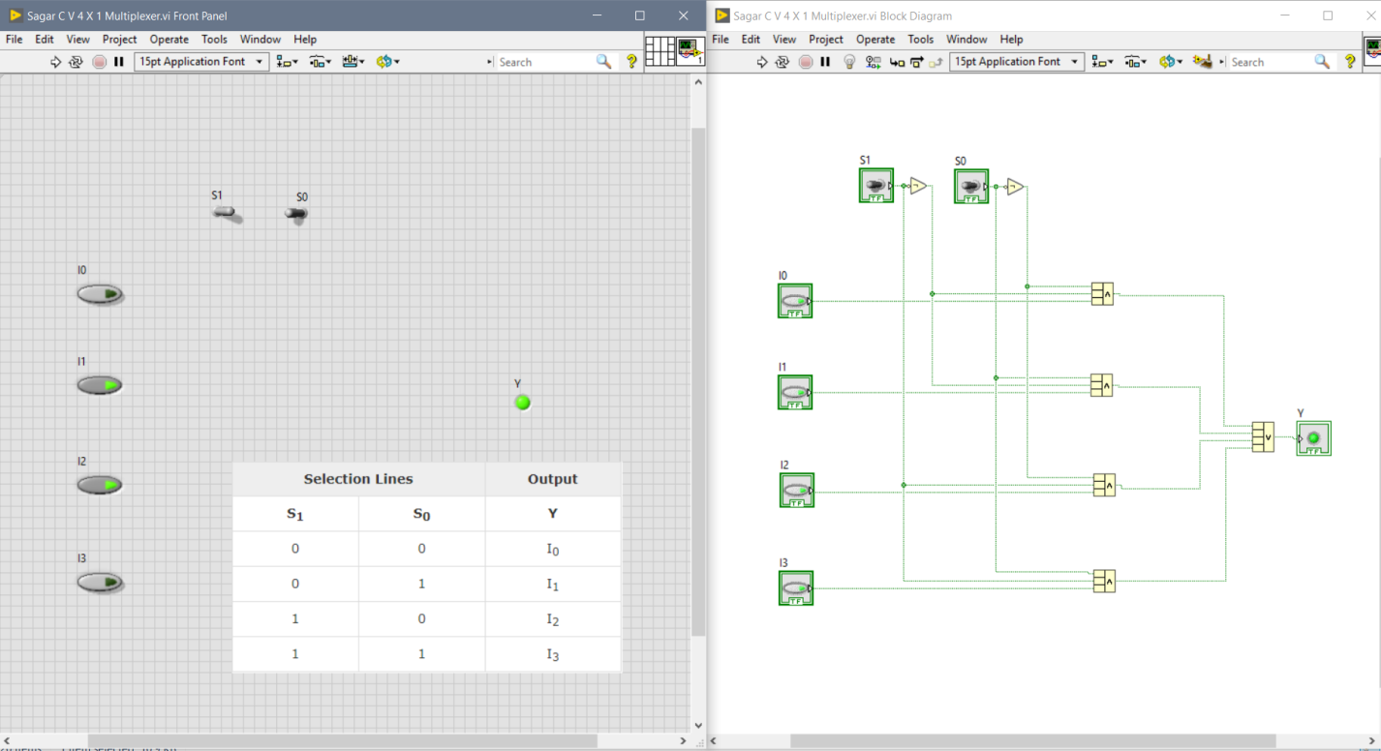

Fig 2. 4:1 Multiplxer on LabVIEW Software

**CONCLUSION**

Hence we created VI to implement 4 : 1 Multiplexer using the Labview Software

**ASSIGNMENT QUESTIONS 1**

**DATE: 25th August, 2021**

**Q1.** Create a VI to realize all Basic gates using NAND Gates and NOR GATES

**THEORY**

A universal gate is a gate which can implement any Boolean function without need to use any other gate type. The NAND and NOR gates are universal gates. In practice, this is advantageous since NAND and NOR gates are economical and easier to fabricate and are the basic gates used in all IC digital logic families. In fact, an AND gate is typically implemented as a NAND gate followed by an inverter not the other way around!! Likewise, an OR gate is typically implemented as a NOR gate followed by an inverter not the other way around!!

**OBSERVATIONS**

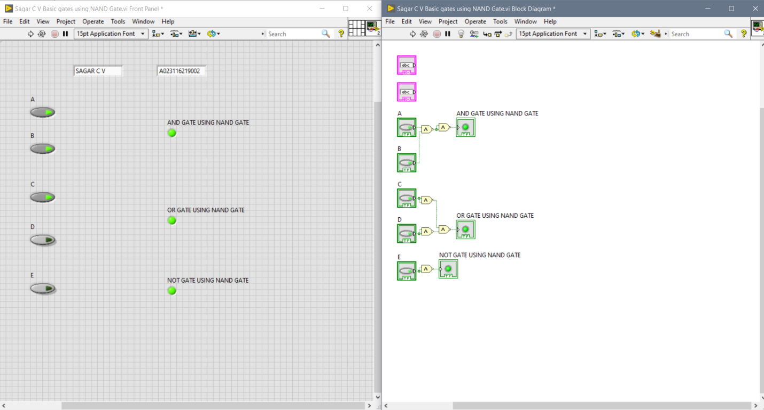

Fig 1. Basic gates using NAND Gates in LABVIEW Software

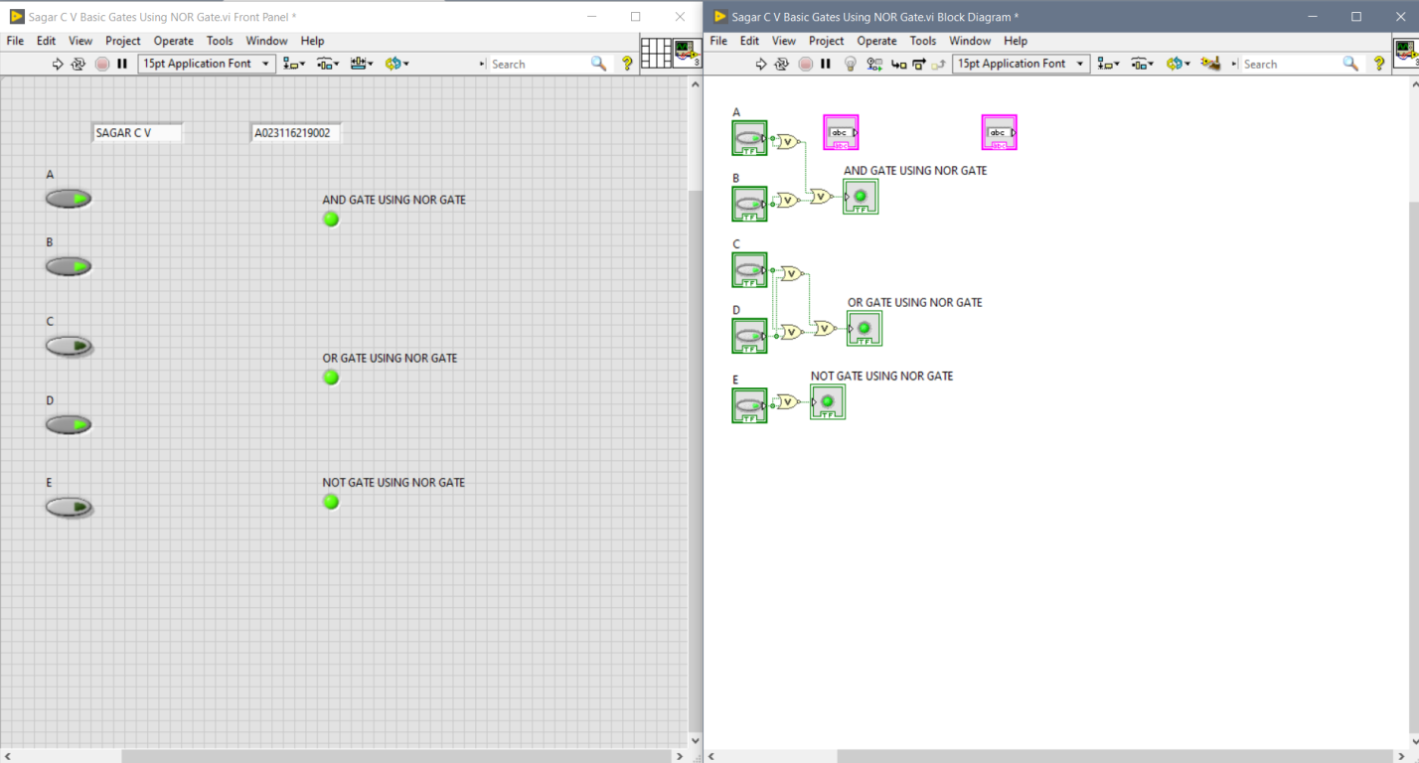

Fig 2. Basic gates using NOR Gates in LABVIEW Software

**Q2.** Create VI to realize all Universal Gates using Basic Gates

**THEORY**

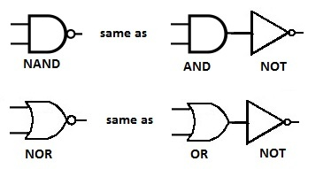

Fig 1. BLOCK Diagram NAND and NOR Gates using BASIC Gates

**OBSERVATIONS**

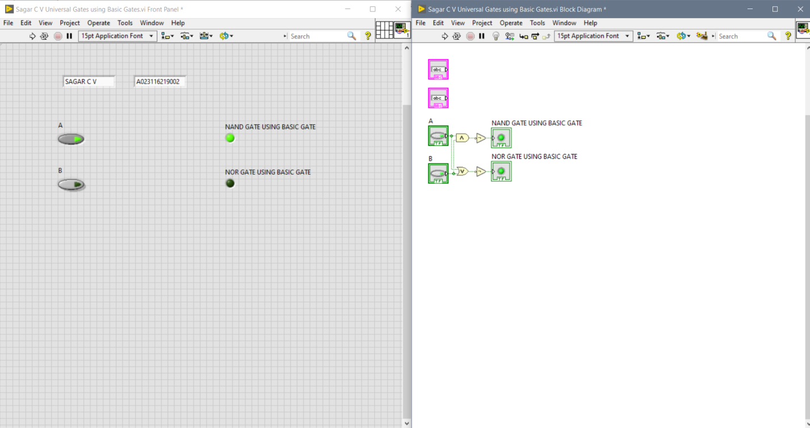

Fig 2. Universal Gates using Basic Gates

**Q3.** Create VI to realize EXOR AND EXNOR using NAND GATES

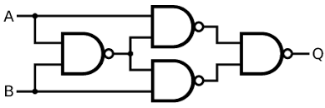

Fig 1. BLOCK Diagram of EXOR gate using NAND GATE

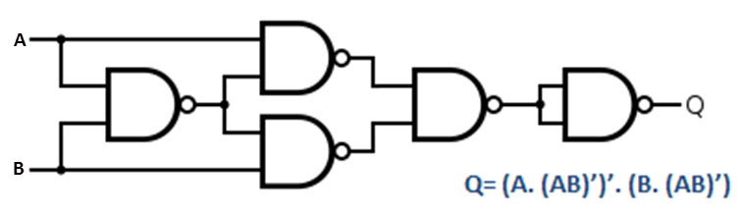

Fig 2. BLOCK Diagram of EXNOR Gate using NAND GATE

**OBSERVATIONS**

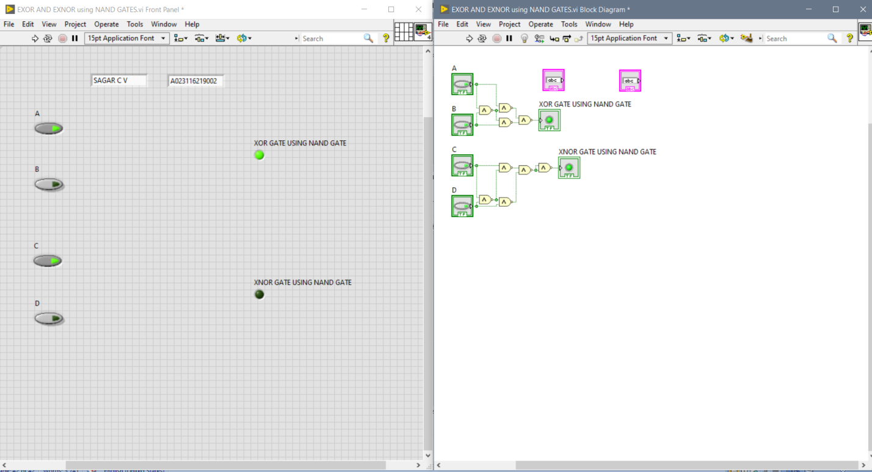

Fig. EXOR AND EXNOR using NAND GATES

**Q4.** Create a VI to realize Y=A’BC+AB’C’+AC using NAND GATES

**THEORY**

Any logic function can be implemented using NAND gates. To achieve this, first the logic function has to be written in Sum of Product (SOP) form. Once logic function is converted to SOP, then is very easy to implement using NAND gate. In other words any logic circuit with AND gates in first level and OR gates in second level can be converted into a NAND-NAND gate circuit.

**OBSERVATIONS**

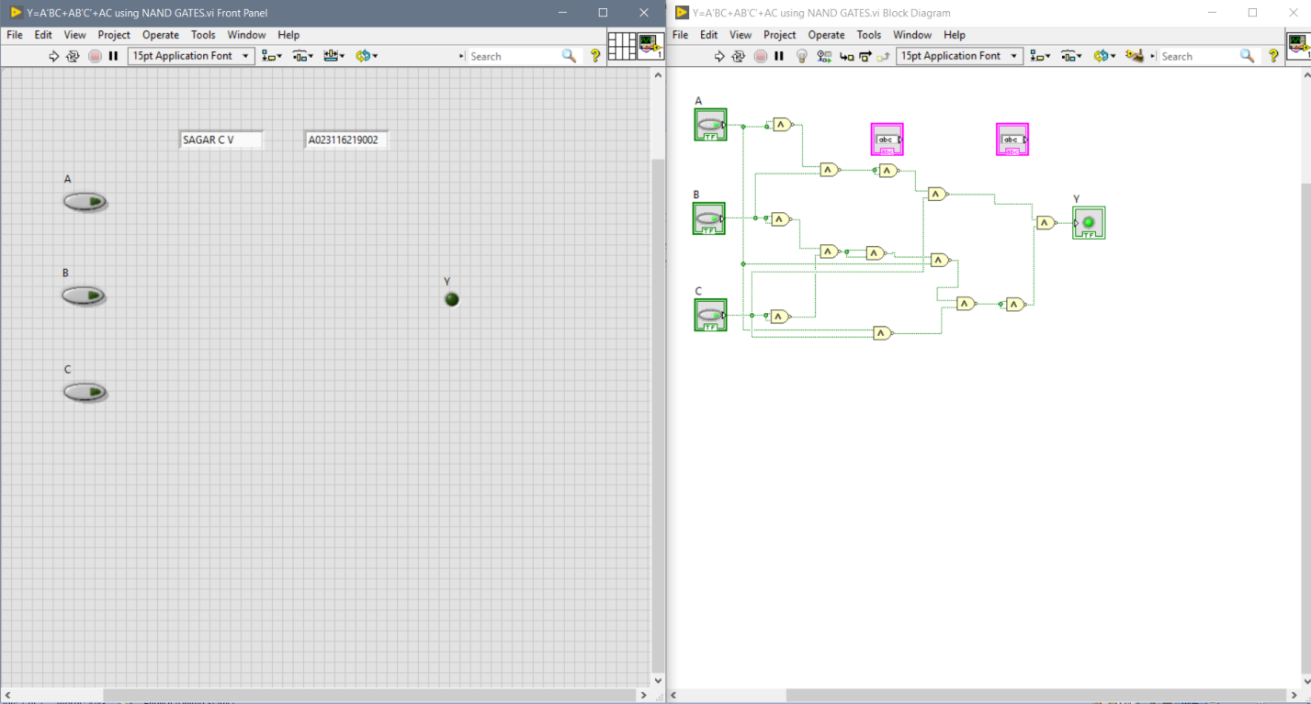

Fig 1. Implementation of Y=A’BC+AB’C’+AC using NAND GATES

**ASSIGNMENT QUESTIONS 2**

**DATE: 29th September, 2021**

**Q1.** Create a VI to implement 2 : 1 Multiplexer using NAND Gates

**THEORY**

## 2-to-1 Multiplexer

A 2-to-1 multiplexer consists of two inputs D0 and D1, one select input S and one output Y. Depending on the select signal, the output is connected to either of the inputs. Since there are two input signals, only two ways are possible to connect the inputs to the outputs, so one select is needed to do these operations.

If the select line is low, then the output will be switched to D0 input, whereas if select line is high, then the output will be switched to D1 input. The figure below shows the block diagram of a 2-to-1 multiplexer which connects two 1-bit inputs to a common destination.

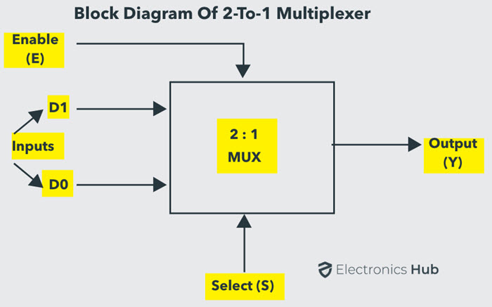

Fig 1. Block Diagram of 2:1 Multiplexer

**OBSERVATIONS**

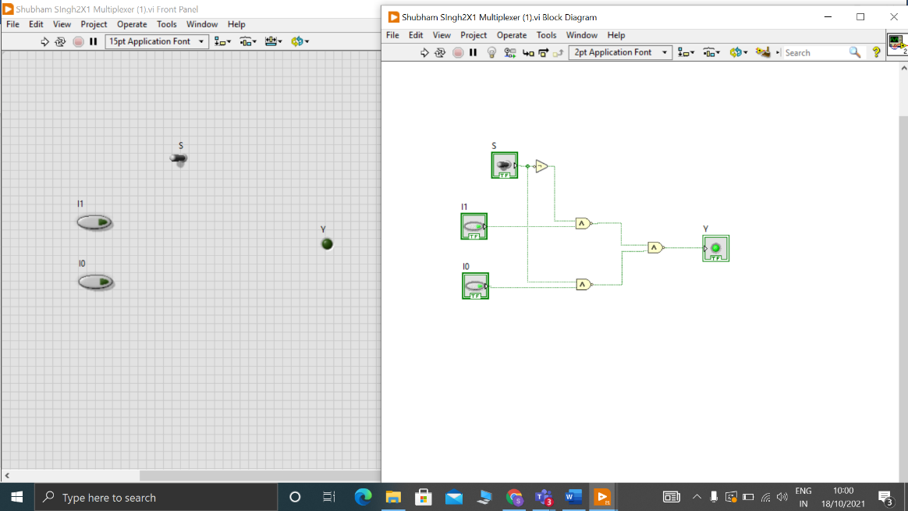

Fig 2. 2:1 MUX Using NAND Gates only on LabVIEW SOFTWARE

**CONCLUSION**

Hence we created VI to implement 2 : 1 Multiplexer using NAND Gates only on the Labview Software

**ASSIGNMENT QUESTIONS 3**

**DATE: 29th September, 2021**

**Q1.** Create a VI to implement [Washing machine control using basic AND & NOT gates](http://vlabs.iitb.ac.in/vlabs-dev/labs/digital_application/experiments/washing-machine-control-pvg/)

**THEORY**

INTRODUCTION

When logic gates are connected together to produce a specific output for certain specific combinations of input variables, with no storage involved, the resulting circuit is called as a *Combinational logic*circuit. The combination of basic gates can be used for a variety of applications such as washing machine control, level monitoring and indicating applications in manufacturing processes, elevator control applications, a warning indicating applications and binary addition -subtraction and multiplication circuits.

APPLICATION:WASHING MACHINE CONTROLLER

For simplicity, consider a three-sensor based washing machine controller namely*Door Sensor, Water Level Sensor and Temperature Sensor*that produce*digital outputs*. Let the controlling action include control of *Water Valve, Heater and Motor*. All these are digitally controlled devices.

CONCEPT

The motor of the washing machine turns ON when the *right temperature*, the *right water level*and obviously when*the door of the machine is closed*.

The system design involves three inputs: D, L & T representing Door position, Level & Temperature respectively. It controls three output devices: W, H & M representing Water Valve, Heater & Motor respectively. Let us decide the logics behind the system:

D = 0 ------- Door Open;

D = 1-------- Door Closed (desired)

L = 0 --------Water Level is LOW;

L = 1 --------Water Level is HIGH (satisfactory)

T = 0 --------Temperature is LOW

T = 1 --------Temperature is HIGH (right value)

The truth table for this application can be developed by logical reasoning:

1. For turning ON of any of the output devices, *the washing machine door/lid should be closed* at any point of time, so only last four cases of the truth table should to be considered where D takes a value 1.
2. If door is closed & water level is LOW, the water valve should be turned ON.
3. If door is closed, water level is satisfactory (HIGH) & the temperature is low, the heater should be turned ON.
4. Whereas when the door is closed, water level is satisfactory and the temperature is right, the motor should turn ON.

Table 1: Truth Table of [Washing machine control using basic AND & NOT gates](http://vlabs.iitb.ac.in/vlabs-dev/labs/digital_application/experiments/washing-machine-control-pvg/)

|  |  |  |  |  |  |
| --- | --- | --- | --- | --- | --- |
| **Door(D)** | **Level(L)** | **Temperature(T)** | **Valve(V)** | **Heater(H)** | **Motor(M)** |
| 0 | 0 | 0 | 0 | 0 | 0 |
| 0 | 0 | 1 | 0 | 0 | 0 |
| 0 | 1 | 0 | 0 | 0 | 0 |
| 0 | 1 | 1 | 0 | 0 | 0 |
| 1 | 0 | 0 | 1 | 0 | 0 |
| 1 | 0 | 1 | 1 | 0 | 0 |
| 1 | 1 | 0 | 0 | 1 | 0 |
| 1 | 1 | 1 | 0 | 0 | 1 |

Considering only those input conditions that produce a HIGH output, we get the reduced Boolean expressions for controlling as follows:

**Water Valve (V) = D.L'**

**Heater (H) = D.L.T'**

**Motor (M) = D.L.T**

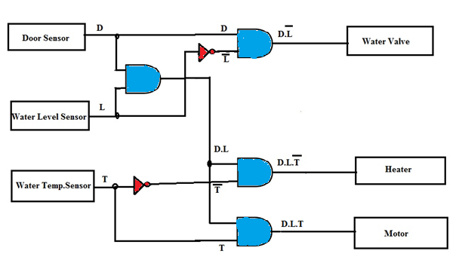

Fig 1. Logic Circuit

**OBSERVATIONS**

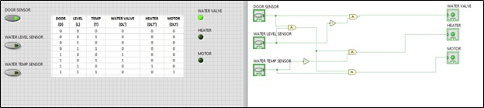

Fig 2.[Washing machine control using basic AND & NOT gates](http://vlabs.iitb.ac.in/vlabs-dev/labs/digital_application/experiments/washing-machine-control-pvg/) on LABVIEW SOFTWARE

**CONCLUSION**

Hence we created VI to implement [Washing machine control using basic AND & NOT gates](http://vlabs.iitb.ac.in/vlabs-dev/labs/digital_application/experiments/washing-machine-control-pvg/) on LABVIEW Software

**Q2.** Create a VI to implement [Seat belt warning system using basic AND & NOT gates](http://vlabs.iitb.ac.in/vlabs-dev/labs/digital_application/experiments/seat-belt-warning-system-pvg/)

**THEORY**

INTRODUCTION

*Combinational logic circuit* is an interconnection of logic gates to generate a specified logic function, where the inputs result in an immediate output. This can be easily understood by the following example. The following English expression describes the way a logic circuit should operate in order to drive a seat-belt warning indicator in a car.

*''If the driver is present AND the driver has NOT buckled up AND the ignition switch is on, then the warning light should turn ON.''*

The Boolean expression for this application can be written as:



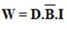

This expression can be easily implemented by using a single- three-input AND gate along with a single NOT gate. This expression could also be implemented by *multi-level logic* , wherein one gate drives an another gate. In general, we may use two - dual-input AND gates and a single NOT gate. Students need to be cautious and judicious while selecting the gates. As the number of levels increases, the response time of the circuit also increases. Multi-level logic leads to the introduction of more time delay as compared to single-level logic with multiple inputs. If it takes τ seconds for a gate to respond to a change in its input and that gate drives a succeeding gate, then it will take 2τ seconds for the entire circuit to respond. It is desirable to minimize the number of levels in the logic. If one needs to construct a truth table for the same, it can be easily prepared by entering 1's and 0's in that expression for various input combinations.

Table 1: Truth Table of [Seat belt warning system using basic AND & NOT gates](http://vlabs.iitb.ac.in/vlabs-dev/labs/digital_application/experiments/seat-belt-warning-system-pvg/)

|  |  |  |  |
| --- | --- | --- | --- |
| **D** | **B** | **I** | **Y= D. B'. I** |
| 0 | 0 | 0 | 0 |
| 0 | 0 | 1 | 0 |
| 0 | 1 | 0 | 0 |
| 0 | 1 | 1 | 0 |
| 1 | 0 | 0 | 0 |
| 1 | 0 | 1 | 1 |
| 1 | 1 | 0 | 0 |
| 1 | 1 | 1 | 0 |

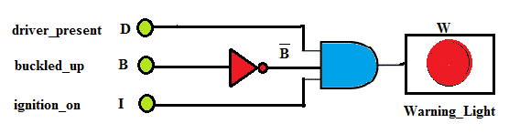

Fig 1. Logic Circuit

**OBSERVATIONS**

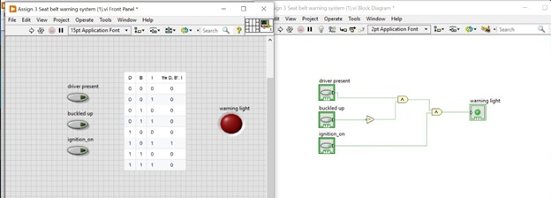

Fig 2. [Seat belt warning system using basic AND & NOT gates](http://vlabs.iitb.ac.in/vlabs-dev/labs/digital_application/experiments/seat-belt-warning-system-pvg/) on LABVIEW Software

**CONCLUSION**

Hence we created VI to implement [Seat belt warning system using basic AND & NOT gates](http://vlabs.iitb.ac.in/vlabs-dev/labs/digital_application/experiments/seat-belt-warning-system-pvg/) on LABVIEW Software

**Q3.** Create a VI to implement [Electronic lock using basic logic gates](http://vlabs.iitb.ac.in/vlabs-dev/labs/digital_application/experiments/electronic-lock-pvg/)

**THEORY**

INTRODUCTION

A typical travel suitcase/bag is provided with a 3-digit or a 4-digit security code lock that unlocks for only a predefined combination of these digits. An electronic lock is a digital combinational circuit that is analogous to the travel suitcase code lock. An electronic lock opens (output goes high) only for certain combinations of the digital inputs. For a 3-digit code lock, there would be in all 2^3 i.e. 8 combinations whereas for a 4-digit there would be 2^4 i.e. 16 combinations of the input. In this experiment, the design steps for a 4-digit electronic lock that operates for two code combinations are explained. Based on the userâ€™s need an electronic code lock can be designed so as to operate with multiple combinations of inputs using basic logic gates. Moreover, the lock can be made more secure by increasing the number of digits.

1.1 CONCEPT:

The electronic lock is designed with four inputs ABCD. A HIGH output will open the lock and the LED turns ON. Let us consider that two combinations of input switches (0001 or 1011) generate a 1(HIGH) at the output and opens the lock.

2 DESIGN STEPS

1. Prepare a truth table with A, B, C and D as four inputs resulting in 16 possible combinations (optional).
2. Convert the truth table information into a Boolean expression. Form the Minterm Boolean expression for the electronic lock circuit.

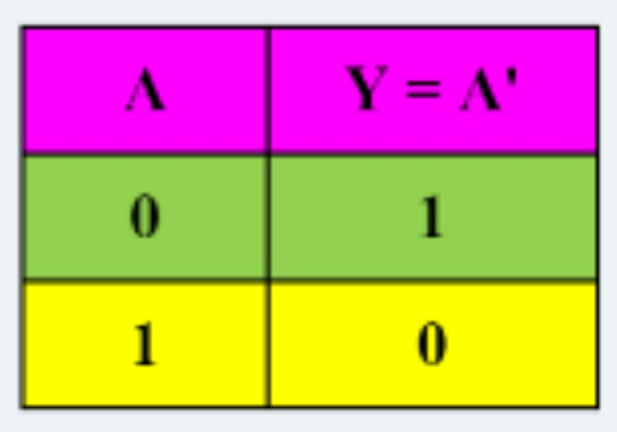

Fig 1. Truth table of [Electronic lock using basic logic gates](http://vlabs.iitb.ac.in/vlabs-dev/labs/digital_application/experiments/electronic-lock-pvg/)

D generate a logical 1 at the output. The two combinations that open the lock are

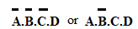

When these two combinations are ORed together they result in a Boolean expression for this application. Minterm Minterm Boolean expression for electronic lock:

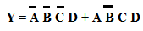

With a view to use two-input gates, the expression can be rearranged as:

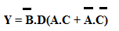

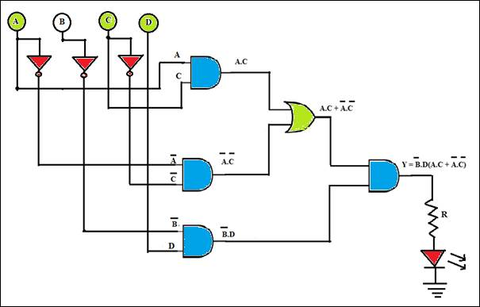

Fig 2. Logic Diagram

**OBSERVATIONS**

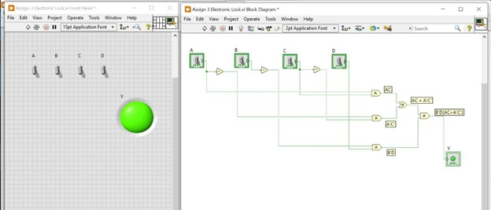

Fig 3. [Electronic lock using basic logic gates](http://vlabs.iitb.ac.in/vlabs-dev/labs/digital_application/experiments/electronic-lock-pvg/) on LABVIEW SOFTWARE

**CONCLUSION**

Hence we created VI to implement [Electronic lock using basic logic gates](http://vlabs.iitb.ac.in/vlabs-dev/labs/digital_application/experiments/electronic-lock-pvg/) on LABVIEW Software

**Q4.** Create a VI to implement Basics of AND gate and its application in car wiper control

**THEORY**

INTRODUCTION

AND, OR and NOT gates are basic logic gates and are fundamental building blocks from which all other logic circuits and digital systems can be constructed. Simple car wiper control, automatic door and window lock, control circuitry in a telephone exchange, logic steering in industrial controls, level controls in storage tanks, speed control, robots and many other monitoring and control circuits make use of digital logic gates. In all such applications, the logical concepts are extensively used to take decisions based on status of some input parameters and in turn control some appliances/devices.

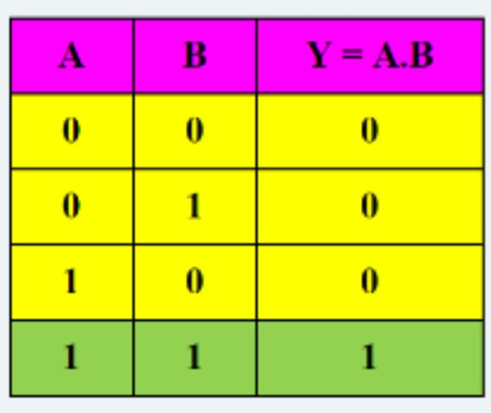

Fig 1. Truth Table AND Gate

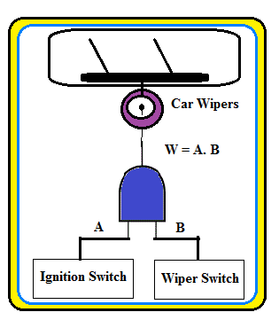

Fig 2. CAR Wiper concept

**OBSERVATIONS**

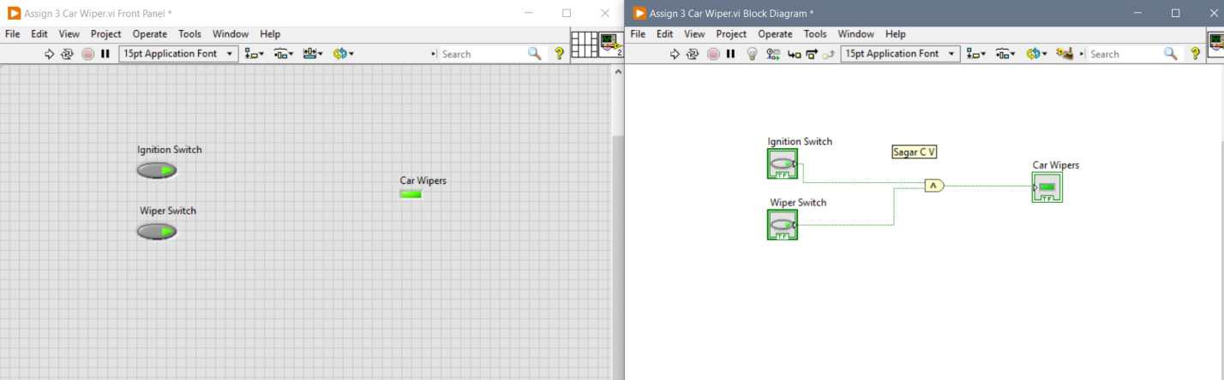

Fig 3. [Electronic lock using basic logic gates](http://vlabs.iitb.ac.in/vlabs-dev/labs/digital_application/experiments/electronic-lock-pvg/) using LABVIEW Software

**CONCLUSION**

Hence we created VI to implement Basics of AND gate and its application in car wiper control

on LABVIEW Software

**Q5.** Create a VI to implement [XOR gate and its application in staircase light control](http://vlabs.iitb.ac.in/vlabs-dev/labs/digital_application/experiments/staircase-light-control-pvg/)

**THEORY**

INTRODUCTION

Two special logic gates that are of fundamental importance and are used more often in digital systems are the Exclusive-OR (XOR) and Exclusive-NOR (XNOR) circuits. XOR and XNOR gates are formed by a combination of AND-OR-INVERT (AOI) logic. This application demonstrates the use of logic gates that simulates a 2-way switch like the ones in our homes to turn a staircase light ON/ OFF from switches located on two different floors.

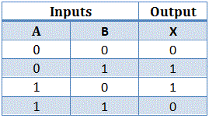

Fig 1. Truth Table of XOR Gate

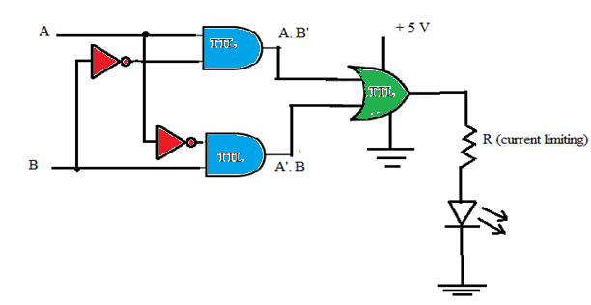

Fig 2. Logic Circuit

**OBSERVATIONS**

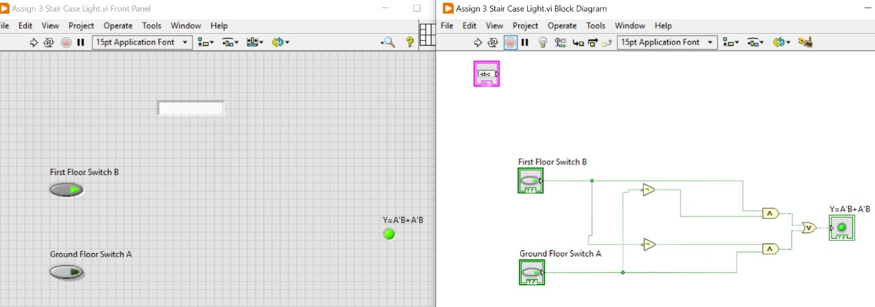

Fig 3. [XOR gate and its application in staircase light control](http://vlabs.iitb.ac.in/vlabs-dev/labs/digital_application/experiments/staircase-light-control-pvg/) using LABVIEW Software

**CONCLUSION**

Hence we created VI to implement [XOR gate and its application in staircase light control](http://vlabs.iitb.ac.in/vlabs-dev/labs/digital_application/experiments/staircase-light-control-pvg/) on LABVIEW Software